CSAF Common Vulnerability Reporting Framework (CVRF) Version 1.2

Working Draft 01

12 March 2017

Technical Committee:

[OASIS Common Security Advisory Framework (CSAF) TC](https://www.oasis-open.org/committees/csaf/)

Chair:

Omar Santos ([os@cisco.com](mailto:os@cisco.com)), [Cisco Systems](http://www.cisco.com/)

Editor:

Stefan Hagen ([stefan@hagen.link](mailto:stefan@hagen.link)), Individual

Additional artifacts:

This prose specification is one component of a Work Product that also includes:

* XML schemas: <http://docs.oasis-open.org/csaf/csaf-cvrf/v1.2/csd01/schemas/>

Related work:

This specification replaces or supersedes:

* *The Common Vulnerability Reporting Framework (CVRF) Version 1.1*. May 2012. ICASI. <http://www.icasi.org/the-common-vulnerability-reporting-framework-cvrf-v1-1/>.

Declared XML namespaces:

* <http://docs.oasis-open.org/csaf/ns/csaf-cvrf/v1.2/common>
* <http://docs.oasis-open.org/csaf/ns/csaf-cvrf/v1.2/cvrf>
* <http://docs.oasis-open.org/csaf/ns/csaf-cvrf/v1.2/prod>
* <http://docs.oasis-open.org/csaf/ns/csaf-cvrf/v1.2/vuln>

Abstract:

The CSAF Common Vulnerability Reporting Framework (CVRF) Version 1.2 is the definitive reference for the CVRF language which supports creation, update, and interoperable exchange of security advisories as structured information on products, vulnerabilities and the status of impact and remediation among interested parties.

Status:

This [Working Draft](https://www.oasis-open.org/policies-guidelines/tc-process" \l "dWorkingDraft) (WD) has been produced by one or more TC Members; it has not yet been voted on by the TC or [approved](https://www.oasis-open.org/policies-guidelines/tc-process" \l "committeeDraft) as a Committee Draft (Committee Specification Draft or a Committee Note Draft). The OASIS document [Approval Process](https://www.oasis-open.org/policies-guidelines/tc-process" \l "standApprovProcess) begins officially with a TC vote to approve a WD as a Committee Draft. A TC may approve a Working Draft, revise it, and re-approve it any number of times as a Committee Draft.

URI patterns:

Initial publication URI:  
http://docs.oasis-open.org/csaf/csaf-cvrf/v1.2/csd01/csaf-cvrf-v1.2-csd01.docx

Permanent “Latest version” URI:  
http://docs.oasis-open.org/csaf/csaf-cvrf/v1.2/csaf-cvrf-v1.2.docx

(Managed by OASIS TC Administration; please don’t modify.)

Copyright © OASIS Open 2017. All Rights Reserved.

All capitalized terms in the following text have the meanings assigned to them in the OASIS Intellectual Property Rights Policy (the "OASIS IPR Policy"). The full [Policy](https://www.oasis-open.org/policies-guidelines/ipr) may be found at the OASIS website.

This document and translations of it may be copied and furnished to others, and derivative works that comment on or otherwise explain it or assist in its implementation may be prepared, copied, published, and distributed, in whole or in part, without restriction of any kind, provided that the above copyright notice and this section are included on all such copies and derivative works. However, this document itself may not be modified in any way, including by removing the copyright notice or references to OASIS, except as needed for the purpose of developing any document or deliverable produced by an OASIS Technical Committee (in which case the rules applicable to copyrights, as set forth in the OASIS IPR Policy, must be followed) or as required to translate it into languages other than English.

The limited permissions granted above are perpetual and will not be revoked by OASIS or its successors or assigns.

This document and the information contained herein is provided on an "AS IS" basis and OASIS DISCLAIMS ALL WARRANTIES, EXPRESS OR IMPLIED, INCLUDING BUT NOT LIMITED TO ANY WARRANTY THAT THE USE OF THE INFORMATION HEREIN WILL NOT INFRINGE ANY OWNERSHIP RIGHTS OR ANY IMPLIED WARRANTIES OF MERCHANTABILITY OR FITNESS FOR A PARTICULAR PURPOSE.

Table of Contents

1 Introduction 6

1.1 Organization of CSAF CVRF 6

1.2 Terminology 6

1.2.1 Terms and Definitions 6

1.2.2 Abbreviated Terms 6

1.3 Normative References 7

1.4 Non-Normative References 7

1.5 Typographical Conventions 8

1.6 Editing Convention 8

2 Design Considerations 9

2.1 Construction Principles 10

2.2 Date and Time 11

3 CSAF CVRF Model Tree Map 12

4 Document (Context) Schema Elements 14

4.1 Document Title 14

4.2 Document Type 15

4.3 Document Publisher 16

4.3.1 Document Publisher – Contact Details 17

4.3.2 Document Publisher – Issuing Authority 17

4.4 Document Tracking 19

4.4.1 Document Tracking – Identification 21

4.4.1.1 Document Tracking – Identification – ID 21

4.4.1.2 Document Tracking – Identification – Alias 21

4.4.2 Document Tracking – Status 22

4.4.3 Document Tracking – Version 22

4.4.4 Document Tracking – Revision History 23

4.4.4.1 Document Tracking – Revision History – Revision 23

4.4.4.1.1 Document Tracking – Revision History – Revision – Number 24

4.4.4.1.2 Document Tracking – Revision History – Revision – Date 24

4.4.4.1.3 Document Tracking – Revision History – Revision – Description 25

4.4.5 Document Tracking – Initial Release Date 25

4.4.6 Document Tracking – Current Release Date 25

4.4.7 Document Tracking – Generator 26

4.4.7.1 Document Tracking – Generator – Engine 26

4.4.7.2 Document Tracking – Generator – Date 26

4.5 Document Notes 28

4.5.1 Document Notes – Note 29

4.6 Document Distribution 30

4.7 Aggregate Severity 30

4.8 Document References 31

4.8.1 Document References – Reference 31

4.8.1.1 Document References – Reference – URL 32

4.8.1.2 Document References – Reference – Description 32

4.9 Acknowledgements 33

4.9.1 Acknowledgements – Acknowledgement 34

4.9.1.1 Acknowledgements – Acknowledgement – Name 34

4.9.1.2 Acknowledgements – Acknowledgement – Organization 35

4.9.1.3 Acknowledgements – Acknowledgement – Description 35

4.9.1.4 Acknowledgements – Acknowledgement – URL 35

5 Product Tree Schema Elements 37

5.1 Product Tree 37

5.1.1 Product Tree – Branch 39

5.1.2 Product Tree – Full Product Name 42

5.1.3 Product Tree – Relationship 42

5.1.4 Product Tree – Product Groups 44

5.1.4.1 Product Tree – Product Groups – Group 46

5.1.4.1.1 Product Tree – Product Groups – Group – Description 46

5.1.4.1.2 Product Tree – Product Groups – Group – Product ID 47

6 Vulnerability Schema Elements 48

6.1 Vulnerability 48

6.2 Vulnerability – Title 50

6.3 Vulnerability – ID 50

6.4 Vulnerability – Notes 51

6.4.1 Vulnerability – Notes – Note 51

6.5 Vulnerability – Discovery Date 52

6.6 Vulnerability – Release Date 52

6.7 Vulnerability – Involvements 53

6.7.1 Vulnerability – Involvements – Involvement 53

6.7.1.1 Vulnerability – Involvements – Involvement – Description 54

6.8 Vulnerability – CVE 55

6.9 Vulnerability – CWE 55

6.10 Vulnerability – Product Statuses 56

6.10.1 Vulnerability – Product Statuses – Status 56

6.10.1.1 Vulnerability – Product Statuses – Status – Product ID 57

6.11 Vulnerability – Threats 58

6.11.1 Vulnerability – Threats – Threat 60

6.11.1.1 Vulnerability – Threats – Threat – Description 60

6.11.1.2 Vulnerability – Threats – Threat – Product ID 61

6.11.1.3 Vulnerability – Threats – Threat – Group ID 62

6.12 Vulnerability – CVSS Score Sets 63

6.12.1 Vulnerability – CVSS Score Sets – Score Set V2 64

6.12.1.1 Vulnerability – CVSS Score Sets – Score Set V2 – Base Score V2 64

6.12.1.2 Vulnerability – CVSS Score Sets – Score Set V2 – Temporal Score V2 64

6.12.1.3 Vulnerability – CVSS Score Sets – Score Set V2 – Environmental ScoreV2 65

6.12.1.4 Vulnerability – CVSS Score Sets – Score Set V2 – Vector V2 65

6.12.1.5 Vulnerability – CVSS Score Sets – Score Set V2 – Product ID 65

6.12.2 Vulnerability – CVSS Score Sets – Score Set V3 66

6.12.2.1 Vulnerability – CVSS Score Sets – Score Set V3 – Base Score V3 66

6.12.2.2 Vulnerability – CVSS Score Sets – Score Set V3 – Temporal Score V3 66

6.12.2.3 Vulnerability – CVSS Score Sets – Score Set V3 – Environmental ScoreV3 67

6.12.2.4 Vulnerability – CVSS Score Sets – Score Set V3 – Vector V3 67

6.12.2.5 Vulnerability – CVSS Score Sets – Score Set V3 – Product ID 67

6.13 Vulnerability – Remediations 68

6.13.1 Vulnerability – Remediations – Remediation 69

6.13.1.1 Vulnerability – Remediations – Remediation – Description 69

6.13.1.2 Vulnerability – Remediations – Remediation – Entitlement 70

6.13.1.3 Vulnerability – Remediations – Remediation – URL 70

6.13.1.4 Vulnerability – Remediations – Remediation – Product ID 70

6.13.1.5 Vulnerability – Remediations – Remediation – Group ID 71

6.14 Vulnerability – References 71

6.14.1 Vulnerability – References – Reference 72

6.14.1.1 Vulnerability – References – Reference – URL 73

6.14.1.2 Vulnerability – References – Reference – Description 73

6.15 Vulnerability – Acknowledgements 74

6.15.1 Vulnerability – Acknowledgements – Acknowledgement 75

6.15.1.1 Vulnerability – Acknowledgements – Acknowledgement – Name 75

6.15.1.2 Vulnerability – Acknowledgements – Acknowledgement – Organization 75

6.15.1.3 Vulnerability – Acknowledgements – Acknowledgement – Description 76

6.15.1.4 Vulnerability – Acknowledgements – Acknowledgement – URL 76

7 Conformance 78

7.1 Conformance as a CVRF version 1.2 document 78

Appendix A. Acknowledgments 79

Appendix B. Examples 80

B.1 Sample Security Advisory A 80

B.2 Sample Security Advisory B 82

B.3 Sample Security Advisory C 85

B.4 Sample Security Advisory D 86

Appendix C. Revision History 87

# Introduction

## Organization of CSAF CVRF

The specification is split into seven chapters.

## Terminology

The key words “MUST”, “MUST NOT”, “REQUIRED”, “SHALL”, “SHALL NOT”, “SHOULD”, “SHOULD NOT”, “RECOMMENDED”, “MAY”, and “OPTIONAL” in this document are to be interpreted as described in [RFC2119].

### Terms and Definitions

For the purposes of this document, the following applies:

**Advisory** — as in ISO/IEC 29147 [ISO29147]

**Coordinator** — as in ISO/IEC 29147 [ISO29147]

**Finder** — as in ISO/IEC 29147 [ISO29147]

**Online Services** — as in ISO/IEC 29147 [ISO29147]

**Product** — as in ISO/IEC 29147 [ISO29147]

**Remediation** — as in ISO/IEC 29147 [ISO29147]

**Service** — as in ISO/IEC 29147 [ISO29147]

**Vendor** — as in ISO/IEC 29147 [ISO29147]

**Vulnerability** — as in ISO/IEC 29147 [ISO29147]

In the upcoming 2017-03-14 revision it is planned to insert here the glossary for terminology a) linking our concepts to the definitions of e.g. ISO/IEC 29147 terms and b) some specializations useful in CSAF CVRF context — to ease a bit on the repeated clarifications in the element subsections.

### Abbreviated Terms

**CCE** — Common Configuration Enumeration [REF_TODO_EVENTUALLY]

**CPE** — Common Platform Enumeration [CPE23-N]

**CSIRT** — Computer Security Incident Response Team

**CVE** — Common Vulnerabilities and Exposures [REF_TODO_ EVENTUALLY]

**CVSS** — Common Vulnerability Scoring System [CVSS]

**ID** — Identifier

**IT** — Information Technology

**PSIRT** — Product Security Incident Response Team

**SW** — Software]

**URL** — Uniform Resource Locator

**UTC** — Universal Time Coordinated

In the upcoming 2017-03-14 revision it is planned to remove / add based on relevance and replace duplicated definitions with linked references to this sub section.

## Normative References

[RFC2119] Bradner, S., “Key words for use in RFCs to Indicate Requirement Levels”, BCP 14, RFC 2119, March 1997. <http://www.ietf.org/rfc/rfc2119.txt>.

[XML] Extensible Markup Language (XML) 1.0 (Fifth Edition), T. Bray, J. Paoli, M. Sperberg-McQueen, E. Maler, F. Yergeau, Editors, W3C Recommendation, November 26, 2008, <http://www.w3.org/TR/2008/REC-xml-20081126/>.   
Latest version available at <http://www.w3.org/TR/xml>.

[XML-Schema-1] W3C XML Schema Definition Language (XSD) 1.1 Part 1: Structures, S. Gao, M. Sperberg-McQueen, H. Thompson, N. Mendelsohn, D. Beech, M. Maloney, Editors, W3C Recommendation, April 5, 2012,   
<http://www.w3.org/TR/2012/REC-xmlschema11-1-20120405/>.   
Latest version available at <http://www.w3.org/TR/xmlschema11-1/>.

[XML-Schema-2] W3C XML Schema Definition Language (XSD) 1.1 Part 2: DatatypesW3C XML Schema Definition Language (XSD) 1.1 Part 2: Datatypes, D. Peterson, S. Gao, A. Malhotra, M. Sperberg-McQueen, H. Thompson, Paul V. Biron, Editors, W3C Recommendation, April 5, 2012,   
<http://www.w3.org/TR/2012/REC-xmlschema11-2-20120405/>.   
Latest version available at <http://www.w3.org/TR/xmlschema11-2/>.

## Non-Normative References

[CPE23-N] Common Platform Enumeration: Naming Specification Version 2.3, B. Cheikes, D. Waltermire, K. Scarfone, Editors, NIST Interagency Report 7695, August 2011, <http://dx.doi.org/10.6028/NIST.IR.7695>.

[CPE23-M] Common Platform Enumeration: Naming Matching Specification Version 2.3, M. Parmelee, H. Booth, D. Waltermire, K. Scarfone, Editors, NIST Interagency Report 7696, August 2011,<http://dx.doi.org/10.6028/NIST.IR.7696>.

[CPE23-D] Common Platform Enumeration: Dictionary Specification Version 2.3, P. Cichonski, D. Waltermire, K. Scarfone, Editors, NIST Interagency Report 7697, August 2011, <http://dx.doi.org/10.6028/NIST.IR.7697>.

[CPE23-A] Common Platform Enumeration: Applicability Language Specification Version 2.3 (NISTIR 7698), D. Waltermire, P. Cichonski, K. Scarfone, Editors, NIST Interagency Report 7698, August 2011, <http://dx.doi.org/10.6028/NIST.IR.7698>.

[CVSS2] A Complete Guide to the Common Vulnerability Scoring System Version 2.0, P. Mell, K. Scarfone, S. Romanosky, Editors, First.org, Inc. June 2007, <https://www.first.org/cvss/cvss-v2-guide.pdf>.

[CVSS3] Common Vulnerability Scoring System v3.0: Specification Document, FIRST.Org, Inc., December 2015, <https://www.first.org/cvss/cvss-v30-specification-v1.7.pdf>.

[DCMI11] DCMI Metadata Terms v1.1, Dublin Core Metadata Initiative, DCMI Rec., June 14, 2012, <http://dublincore.org/documents/2012/06/14/dcmi-terms/>.  
Latest version available at <http://dublincore.org/documents/dcmi-terms/>.

[ISO8601] Data elements and interchange formats — Information interchange — Representation of dates and times, International Standard, ISO 8601:2004(E), December 1, 2004, <https://www.iso.org/standard/40874.html>.

[ISO29147] Information technology — Security techniques — Vulnerability disclosure, International Standard, ISO 29147:2014(E), February 15, 2014,  
<https://www.iso.org/standard/45170.html>.

[SCAP12] The Technical Specification for the Security Content Automation Protocol (SCAP): SCAP Version 1.2, D. Waltermire, S. Quinn, K. Scarfone, A. Halbardier, Editors, NIST Spec. Publ. 800‑126 rev. 2, September 2011,   
<http://dx.doi.org/10.6028/NIST.SP.800-126r2>.

## Typographical Conventions

Keywords defined by this specification use this monospaced font.

Normative source code uses this paragraph style.

Some sections of this specification are illustrated with non-normative examples.

Example 1: text describing an example uses this paragraph style

Non-normative examples use this paragraph style.

All examples in this document are non-normative and informative only.

Representation-specific text is indented and marked with vertical lines.

Representation-Specific Headline

Normative representation-specific text

All other text is normative unless otherwise labeled.

## Editing Convention

Text highlighted in Light Green within this specification identifies conformance statements. Every conformance statement has been assigned a reference in the format [CSAF-section#-local#].

# Design Considerations

The Common Security Advisory Framework’s (CSAF) Common Vulnerability Reporting Framework (CVRF) is a language to exchange Security Advisories formulated in XML.

The term Security Advisory as used in this document describes any notification of security issues in products of and by providers. Anyone providing a product is considered in this document as a vendor, i.e. developers or maintainers of information system products or services. This includes all authoritative product vendors, Product Security Incident Response Teams (PSIRTs), and product resellers and distributors, including authoritative vendor partners.

A security issue is not necessarily constraint to a problem statement, the focus of the term is on the security aspect impacting (or **not** impacting) specific product-platform-version combinations. Information on **presence** or **absence** of work-arounds is also considered part of the security issue.

This document is the definitive reference for the language elements of CSAF CVRF version 1.2. The encompassing XML schema files noted in the Additional Artifacts section of the title page shall be taken as normative in the case a gap or an inconsistency in this explanatory document becomes evident.

The version 1.2 of the CSAF CVRF allows the users to transition from Common Vulnerability Scoring System (CVSS) version 2 to version 3 as it supports both CVSS versions. Please note that CSAF CVRF 1.2 is **not** backward compatible with CVRF 1.1 published by the Internet Consortium for Advancement of Security on the Internet (ICASI) and contributed to OASIS for future evolution by the Common Security Advisory Framework (CSAF) TC.

The following presentation is grouped by schema, and is not simply derivative documentation from the schema documents themselves. The information contained aims to be more descriptive and complete. Where applicable, common conventions are stated and known common issues in usage are pointed out informatively to support implementers of document producers and consumers alike.

From a high-level perspective, any Security Advisory purported by a CSAF CVRF version 1.2 adhering document (inside the root cvrf:cvrfdoc element) MUST provide at least the following top-level elements in the displayed sequence (Format is “**Concept**: namespace:Element”): [CSAF-2-1]

1. **Title**: cvrf:DocumentTitle
2. **Type**: cvrf:DocumentType
3. **Publisher**: cvrf:DocumentPublisher
4. **Tracking**: cvrf:DocumentTracking

This minimal required set does not provide any useful info on products, vulnerabilities, or security advisories, thus a maximal top-level set of elements is given here below:

1. **Title**: cvrf:DocumentTitle
2. **Type**: cvrf:DocumentType
3. **Publisher**: cvrf:DocumentPublisher
4. **Tracking**: cvrf:DocumentTracking
5. **Notes**: cvrf:DocumentNotes
6. **Distribution**: cvrf:DocumentDistribution
7. **Aggregate Severity**: cvrf:AggregateSeverity
8. **References**: cvrf:DocumentReferences
9. **Acknowledgements**: cvrf:Acknowledgements
10. **Product Tree**: prod:ProductTree
11. **Vulnerability**: vuln:Vulnerability

Care has been taken, to design the containers for product and vulnerability info to support fine-grained mapping of security advisories onto product and vulnerability and minimize data duplication through referencing.

The display of the elements representing **Product Tree** and **Vulnerability** info has been placed in the sections named accordingly.

General design considerations that place CSAF CVRF version 1.2 in the wider context of security advisories are to be found in the section Design Considerations.

As the XML format is not primarily targeting human readers but more programs parsing, validating and transforming no example is given in this introduction but instead examples derived from several real-world security advisories are stated in the non-normative Appendix B Examples.

## Construction Principles

A Security Advisory defined as a CSAF CVRF document is the result of complex orchestration of many players and distinct and partially difficult to play schemas.

Historically the format was chosen as [XML] based on a small set of XSD ([XML-Schema-1], [XML-Schema-2]) schema files spanning a combined namespace anchored at a single root. This was even more so natural, as it aligned well with separation of concerns and shared the format family of information interchange utilized by the providers of product and vulnerability information.

The acronym CSAF, “Common Security Advisory Framework”, stands for the target of concerted mitigation and remediation accomplishment and the name part CVRF, “Common Vulnerability Reporting Framework”, reflects the origin of the orchestrating tasks.

Technically the use of XML allows validation and proof of model conformance (through established schema based validation) of the declared information inside CVRF documents.

The CSAF CVRF schema structures its derived documents into three main classes of the information conveyed:

1. The frame, aggregation, and reference info of the document
2. Product information considered relevant by the creator
3. Vulnerability information and its relation to the products declared in 2.

The prescribed sequence of ordered elements inside these main classes (containers) has been kept stable (e.g. no lexical sorting of sequences) to reduce the amount of changes required for upgrading.

Wherever possible repetition of data has been replaced by linkage through ID elements. Consistency on the content level thus is in the responsibility of the producer of such documents, to link e.g. vulnerability info to the matching product.

A dictionary like presentation of all defined schema elements is given in the following sections. Any expected relations to other elements (linkage) is described there. This linking relies on setting attribute values accordingly (mostly guided by industry best practice and conventions) and thus implies, that any deep validation on a semantic level is to be ensured by the producer and consumer of CSAF CVRF documents. It is out of scope for this specification.

Proven and intended usage patterns from practice are given where possible. Delegation to industry best practices technologies is used in referencing schemas for:

* **Document** **Metadata**:
  + Dublin Core (DC) Metadata Initiative Version 1.1 [DCMI11]
    - XML Namespace http://purl.org/dc/elements/1.1/
* **Platform** **Data**:
  + Common Platform Enumeration (CPE) Version 2.3 [CPE23_A]
    - XML Namespace http://cpe.mitre.org/language/2.0
* **Security** **Content** **Automation**:
  + Security Content Automation Protocol (SCAP) Version 1.2 [SCAP12]
    - XML Namespace http://scap.nist.gov/schema/scap-core/1.0
* **Vulnerability** **Scoring**:
  + Common Vulnerability Scoring System (CVSS) Version 3.0 [CVSS3]
    - XML Namespace https://www.first.org/cvss/cvss-v3.0.xsd
  + Common Vulnerability Scoring System (CVSS) Version 2.0 [CVSS2] [1]
    - XML Namespace <http://scap.nist.gov/schema/cvss-v2/1.0>

## Date and Time

All date time values inside a CSAF CVRF document SHOULD adhere to the ISO 8601 [ISO8601] basic or extended Format (as given there in section 4.3.2 “Complete representations” and with the addition of decimal fractions for seconds, similar to ibid. section 4.2.2.4 “Representations with decimal fraction” but with the full stop (.) being the preferred separator for CSAF CVRF). [CSAF-2.2-1].

Many CSAF CVRF documents are considered to be shared messages with distributed incremental update and forwarding cycles. Universal Time Coordinated (UTC) is the best fit time system for world-wide exchanged and used date time information. UTC is synonymous to Greenwich Mean Time (GMT), “Zero meridian” time, or military “Zulu” time.

To ensure maximal interoperability any date time literal having an empty zone designator SHOULD be treated as having UTC offset 0 or equivalently[2] as if the zone designator would have been the UTC designator (Z). [CSAF-2.2-2]

The following CSAF CVRF date time literals expressed in the language of the ISO8601 abstract representations for digits of year(Y), month(M), day(D), hour(h), minute(m), seconds(s), and the special marker (T) are suggested for maximal interoperability in exchange:

Without fractional second digits (also no “full stop” separator):

YYYYMMDDThhmmssZ

YYYYMMDDThhmmss+hhmm

YYYY-MM-DDThh:mm:ssZ

YYYY-MM-DDThh:mm:ss+hh:mm

Including fractional second digits:

YYYYMMDDThhmmss.sZ

YYYYMMDDThhmmss.s+hhmm

YYYY-MM-DDThh:mm:ss.sZ

YYYY-MM-DDThh:mm:ss.s+hh:mm

The T separator literal SHOULD be kept, as leaving it out it is not expected to safe significant space but instead challenge interoperability. [CSAF-2.2-3]

Note: Time zone calculations are not considered to be in scope for this specification.

Examples

Example 2: Basic format results in April 30, 1985 at time 23:15:30.0 UTC (due to Z as zone designator for UTC)

19850430T231530.0Z

Example 3: Basic format results in April 30, 1985 at time 23:15:30.0 UTC (due to +0400 offset i.e. 4 hours’ positive difference between the time scale of local time and UTC)

19850501T031530.0+0400

Example 4: Extended format results in April 30, 1985 at time 23:15:30.0 UTC (due to Z as zone designator for UTC)

1985-04-30T23:15:30.0Z

Example 5: Extended format for April 30, 1985 at time 23:15:30.0 UTC (due to +01:00 offset i.e. 1 hour’ positive difference between the time scale of local time and UTC)

1985-05-01T00:15:30.0+01:00

# CSAF CVRF Model Tree Map

To assist navigating the topology of the CSAF CVRF version 1.2 document schema, a graphical tree rendering of the parent-child-grandchild relations among the elements under the single cvrf:cvrfdoc root is provided in Figure 1.

Visual Overview

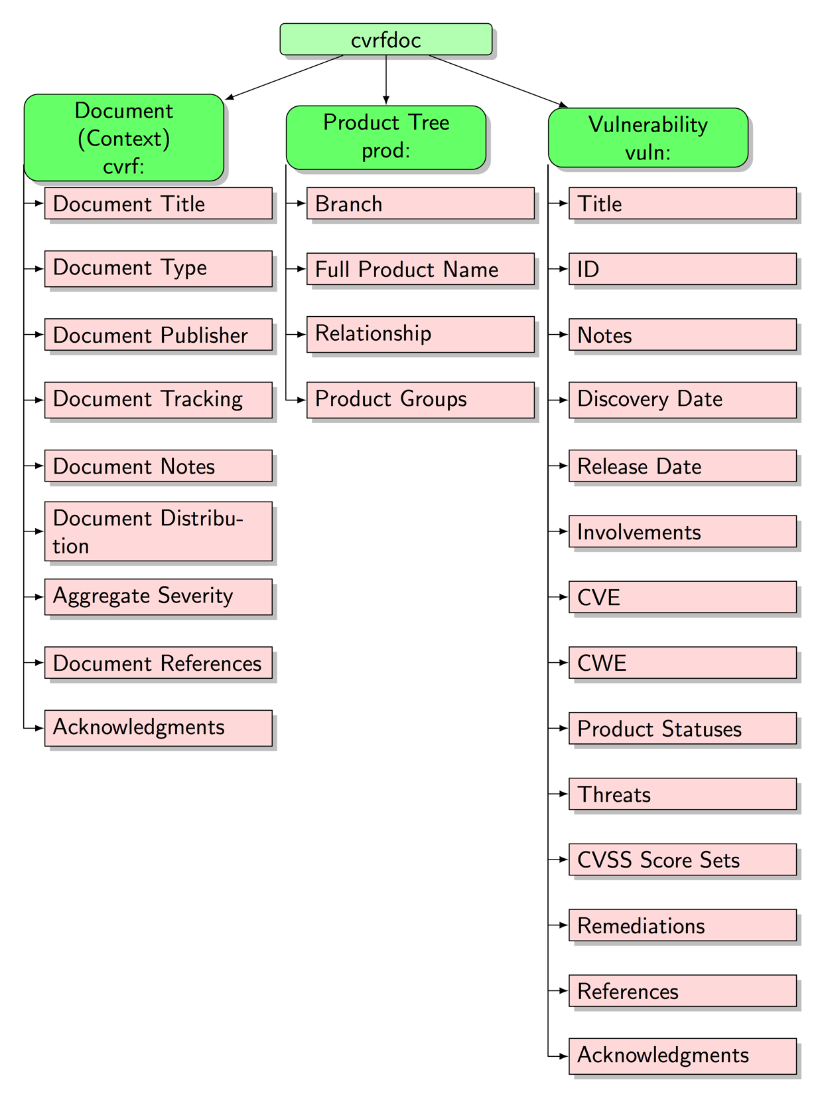

Figure 1: First and second level sectioning below the cvrf:cvrfdoc root is being considered / reworked.

Visual Overview

Map of some global and valid **CSAF CVRF Document** configuration:

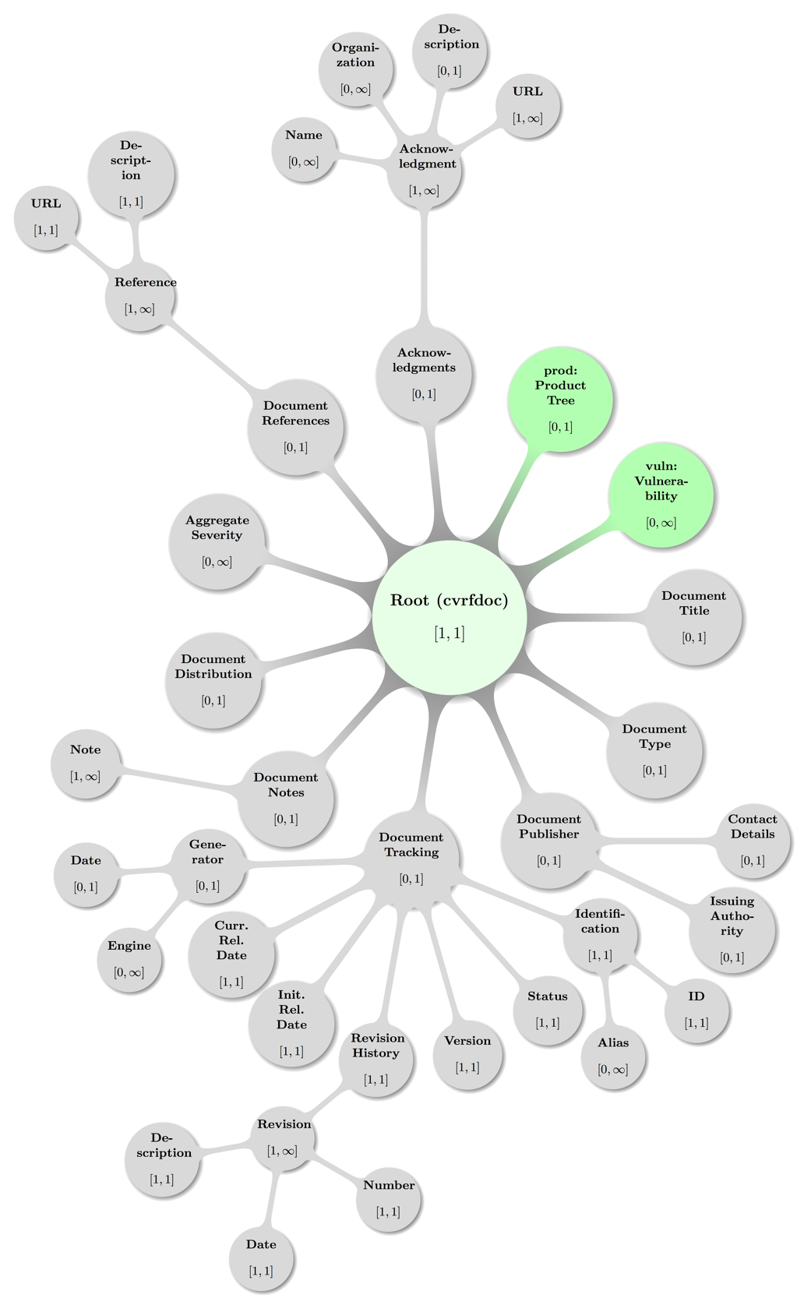

Figure 2: Visual topological presentation of abstract valid **CSAF CVRF Document Root** configuration.

Some decent coloring has been applied to above graph to balance visual hints with accessibility. The mathematical closed interval notation has been used to annotate the minimum and maximum occurrences of elements, where the infinity symbol (∞) translates to the term unbounded in XML lingo.

# Document (Context) Schema Elements

The nine top-level elements are defined in the cvrf XML schema file and if given MUST appear in the order listed below and as children of the cvrf:cvrfdoc single root element. [CSAF-4-1]

These main constituents in sequence (Format is “**Concept**: namespace:Element”) are:

1. Title: cvrf:DocumentTitle
2. Type: cvrf:DocumentType
3. Publisher: cvrf:DocumentPublisher
4. Tracking: cvrf:DocumentTracking
5. Notes: cvrf:DocumentNotes
6. Distribution: cvrf:DocumentDistribution
7. Aggregate Severity: cvrf:AggregateSeverity
8. References: cvrf:DocumentReferences
9. Acknowledgements: cvrf:Acknowledgements

The remaining sub sections will describe the elements, requirements on them and state recommendations and examples.

As a service to the reader otherwise commonly used acronyms used in the rest of this section (or found in the XML schema source files are expanded here and as understood in the context of CVRF (for more details please cf. the respective sub sections below):

* CVSS: Common Vulnerability Scoring System (cf. [CVSS3] preferred, [CVSS2] deprecated)
* OID: Object Identifier (here unique address in hierarchical management information base)
* UTC: Universal Time Coordinated (cf. section 2.2 Date and Time)

## Document Title

cvrf:DocumentTitle

**Data Type:** string  
**Range:** unrestricted  
**Minimum Occurrences:** 1  
**Maximum Occurrences:** 1  
**Parent:** Root

The element cvrf:DocumentTitleholds a definitive canonical name for the document, providing enough descriptive content to differentiate from other similar documents, ideally providing a unique “handle” While this field is largely up to the document producer, common usage brings some recommendations:

The title should be succinct and promptly give the reader an idea of what is to come. If the document producer also publishes a human-friendly document that goes hand-in-hand with a CVRF document, it is recommended that both documents use the same title. It is further recommended to include the manufacturer name with any product names mentioned in the title.

Examples

Example 6:

<DocumentTitle>Cisco IPv6 Crafted Packet Vulnerability</DocumentTitle>

Example 7:

<DocumentTitle>CERT Vulnerabilities in Kerberos 5 Implementation</DocumentTitle>

Example 8:

<DocumentTitle>Cisco Content Services Switch 11000 Series DNS Negative Cache of Information  Denial-of-Service Vulnerability</DocumentTitle>

Example 9:

<DocumentTitle>Symantec Brightmail AntiSpam Static Database Password</DocumentTitle>

Example 10:

<DocumentTitle>HPSBUX02697 SSRT100591 rev.1 - HP-UX Running Java, Remote Unauthorized Access, Disclosure of Information, and Other Vulnerabilities</DocumentTitle>

Example 11:

<DocumentTitle>Microsoft Vulnerability in the Microsoft Data Access Components (MDAC) Function Could Allow Code Execution</DocumentTitle>

Example 12:

<DocumentTitle>  
 Microsoft Vulnerability in Windows Explorer Could Allow Remote Code  Execution  
</DocumentTitle>

## Document Type

cvrf:DocumentType

**Data Type:** string  
**Range:** unrestricted  
**Minimum Occurrences:** 1  
**Maximum Occurrences:** 1  
**Parent:** Root

Theelementcvrf:DocumentTypedefines a short canonical name, chosen by the document producer, which will inform the end user as to the type of document.

Examples

Example 13:

<DocumentType>Vulnerability Report</DocumentType>

Example 14:

<DocumentType>Security Bulletin</DocumentType>

Example 15:

<DocumentType>Security Notice</DocumentType>

## Document Publisher

cvrf:DocumentPublisher

**Data Type:** string  
**Minimum Occurrences:** 1  
**Maximum Occurrences:** 1  
**Parent:** Root  
**Children:** Contact Details, Issuing Authority  
**Attribute:** Type, Vendor ID  
**Attribute Data Type:** enumerated list, string  
**Attribute Range:** {Vendor, Discoverer, Coordinator, User, Other}, unrestricted  
**Attribute Required:** yes, no

Theelementcvrf:DocumentPublisheris a container that holds all the information about the publisher of the CSAF CVRF document, including attributes denoting the Type of publisher and an optional Vendor ID as well as optional elements for **Contact Details** and **Issuing Authority**.

Visual Overview

Map of some valid **Document Publisher** configuration including the parent node (**Root**):

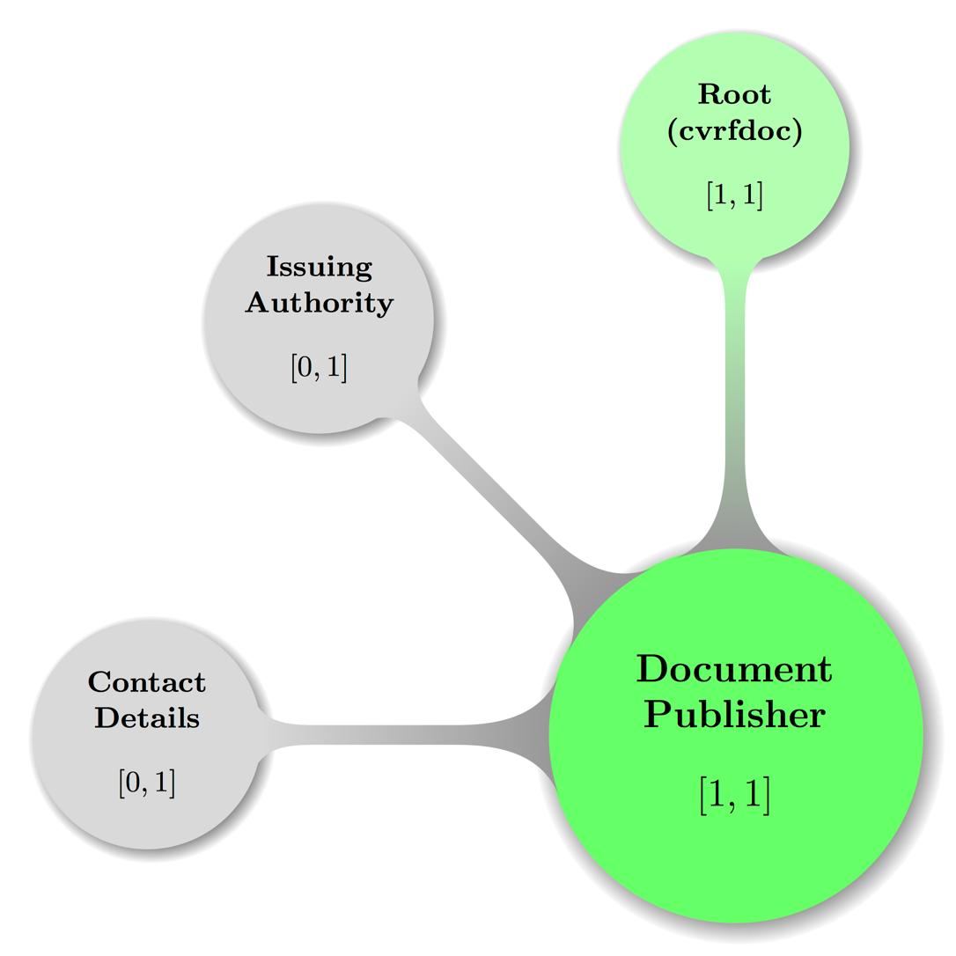

Figure 3: Visual presentation of abstract but topologically valid **Document Publisher** configuration.

Some decent coloring has been applied to above graph to balance visual hints with accessibility. The mathematical closed interval notation has been used to annotate the minimum and maximum occurrences of elements.

**Document Publisher** is a required element, but the only required data is the *Type* attribute. The **Document Publisher** *Type* attribute is an enumerated list containing an array of different document publisher types. Types include:

* **Vendor**: Developers or maintainers of information system products or services. This includes all authoritative product vendors, Product Security Incident Response Teams (PSIRTs), and product resellers and distributors, including authoritative vendor partners.
* **Discoverer**: Individuals or organizations that find vulnerabilities or security weaknesses. This includes all manner of researchers.
* **Coordinator**: Individuals or organizations that manage a single vendor’s response or multiple vendors’ responses to a vulnerability, a security flaw, or an incident. This includes all Computer Emergency/Incident Response Teams (CERTs/CIRTs) or agents acting on the behalf of a researcher.
* **User**: Anyone using a vendor’s product.
* **Other**: Catchall for everyone else. Currently this includes editors, reviewers, forwarders, republishers, language translators, and miscellaneous contributors.

The optional *Vendor ID* attribute is a unique objet identifier (OID) that a vendor uses as issued by FIRST under the auspices of IETF. At the time of this writing, OID is a work in progress.

Example

Example 16:

<DocumentPublisher Type="Vendor" VendorID="MarcusCom"/>

### Document Publisher – Contact Details

cvrf:DocumentPublisher / cvrf:ContactDetails

**Data Type:** string  
**Range:** unrestricted  
**Minimum Occurrences:** 0  
**Maximum Occurrences:** 1  
**Parent:** Document Publisher

Theoptional Document Publisher elementcvrf:ContactDetailscontains information required to contact the document publisher.

Example

Example 17:

<ContactDetails>

Name: Birgit Mustermensch\r\nOrganization: Internationale Sicherheit für Alle\r\n  
 Phone Number: 004912345678901\r\nFax Number: 004912345678902\r\n  
 Email Address: birgit.mustermensch@example.com  
</ContactDetails>

### Document Publisher – Issuing Authority

cvrf:DocumentPublisher / cvrf:IssuingAuthority

**Data Type:** string  
**Range:** unrestricted  
**Minimum Occurrences:** 0  
**Maximum Occurrences:** 1  
**Parent:** Document Publisher

Theoptional Document Publisher elementcvrf:IssuingAuthoritystates the name of the issuing party and that party’s authority to release the document. In particular, it addresses the party’s constituency and responsibilities or other obligations. This element should also include instructions for contacting the issuer.

Example

Example 18:

<IssuingAuthority>

The Juniper SIRT (Juniper Networks Security Incident Response Team) is the sole   
 authority regarding vulnerabilities in any Juniper Networks products or services,   
 and coordinates the handling of all aspects of such vulnerabilities from initial   
 discovery or report through public announcements and any subsequent follow-on   
 activities. Additional information is available at   
 http://www.juniper.net/support/security/report_vulnerability.html  
</IssuingAuthority>

## Document Tracking

cvrf:DocumentTracking

**Data Type:** container  
**Minimum Occurrences:** 1 (required)  
**Maximum Occurrences:** 1  
**Parent:** Root  
**Children:** Identification, Status, Version, Revision History, Initial Release Date, Current Release Date, Generator

Theelement cvrf:DocumentTrackingis a container designated to hold all management attributes necessary to track a CVRF document as a whole.

Visual Overview

Map of some valid **Document Tracking** configuration including the parent node (**Root**):

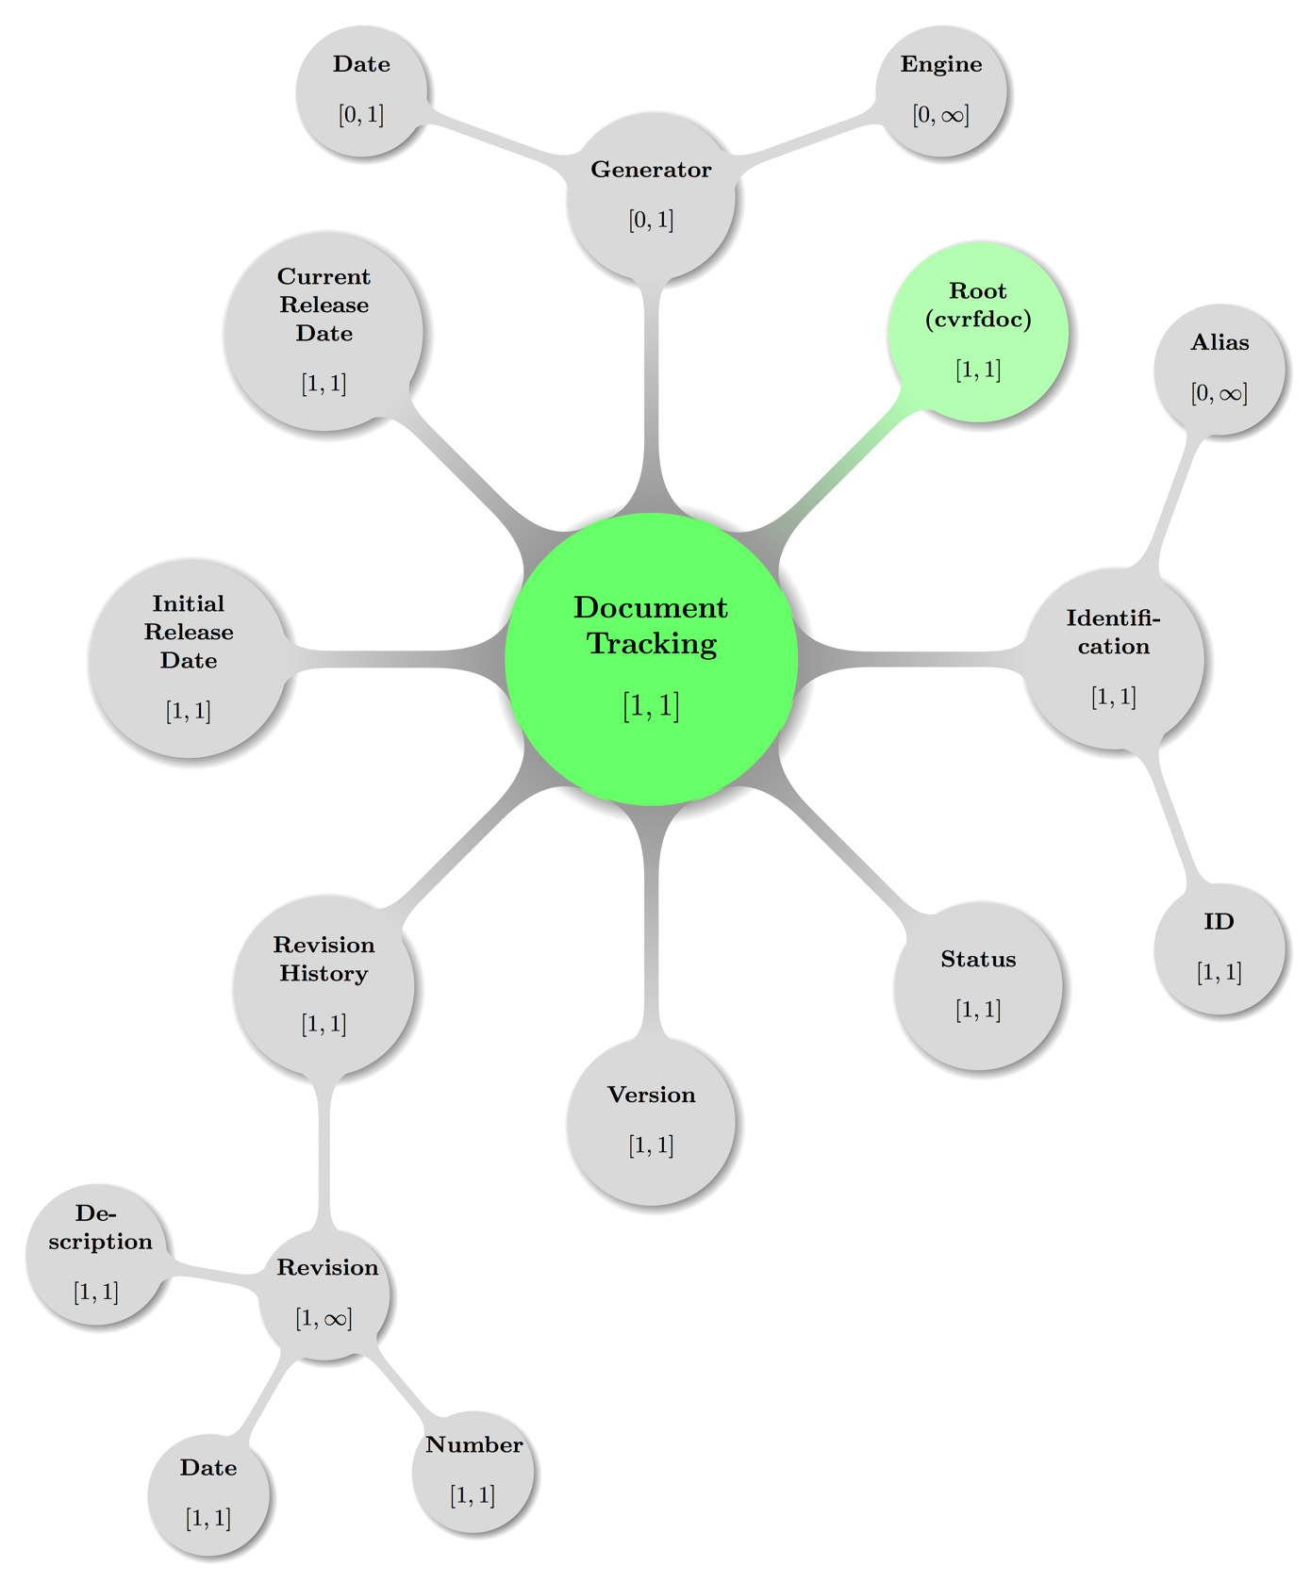

Figure 4: Visual presentation of abstract but topologically valid **Document Tracking** configuration.

Some decent coloring has been applied to above graph to balance visual hints with accessibility. The mathematical closed interval notation has been used to annotate the minimum and maximum occurrences of elements, where the infinity symbol (∞) translates to the term unbounded in XML lingo.

Example

See Example 28

### Document Tracking – Identification

cvrf:DocumentTracking / cvrf:Identification

**Data Type:** container  
**Minimum Occurrences:** 1  
**Maximum Occurrences:** 1  
**Parent:** Document Tracking

TheDocument Tracking elementcvrf:Identificationis a container that holds all the identifiers for the CVRF document. Required is the **ID** element, optional is the **Alias** element.

Example

See Example 28

#### Document Tracking – Identification – ID

cvrf:DocumentTracking / cvrf:Identification / cvrf:ID

**Data Type:** string  
**Range:** unrestricted  
**Minimum Occurrences:** 1  
**Maximum Occurrences:** 1  
**Parent:** Identification

Theelementcvrf:IDis a short, unique identifier used to refer to the document unambiguously in any context. The ID is a simple label. It is a string data type to provide for a wide range of numbering values, types, and schemes. Typically, the ID should be assigned and maintained by the original document issuing authority. It is recommended that the ID be a monotonically increasing value, or increasing in such a predictable manner that it does not contribute toward confusion or misnumbering. Careful consideration is required to ensure that construction of the ID does not contribute to confusion or collision with other labels.

Example

See Example 28

#### Document Tracking – Identification – Alias

cvrf:DocumentTracking / cvrf:Identification / cvrf:Alias

**Data Type:** string  
**Range:** unrestricted  
**Minimum Occurrences:** 0  
**Maximum Occurrences:** unbounded  
**Parent:** Identification

The optionalelementcvrf:Aliasis an optional alternative ID used to refer to the document. Many vendors have one or more alternative or secondary IDs for documents and the **Alias** presents an interface to publish those alongside the primary ID.

Example

See Example 28

### Document Tracking – Status

cvrf:DocumentTracking / cvrf:Status

**Data Type:** enumerated list  
**Range:** {Draft, Interim, Final}  
**Minimum Occurrences:** 1  
**Maximum Occurrences:** 1  
**Parent:** Document Tracking

Theelementcvrf:Statuscontentrefers to the condition of the document with regard to completeness and the likelihood of future editions.

Status types are:

* **Draft**: Pre-release, intended for issuing party’s internal use only, or possibly used externally when the party is seeking feedback or indicating its intentions regarding a specific issue.
* **Interim**: The issuing party believes the content is subject to change.
* **Final**: The issuing party asserts the content is unlikely to change. “Final” status is an indication only, and does not preclude updates.

Issuing parties are strongly recommended to set Status to “Draft” when initiating a new document and to implement procedures to ensure that the status is changed to the appropriate value before the document is released.

Examples

See Example 28

### Document Tracking – Version

cvrf:DocumentTracking / cvrf:Version

**Data Type:** token  
**Range:** unrestricted.unrestricted.unrestricted.unrestricted  
**Minimum Occurrences:** 1  
**Maximum Occurrences:** 1  
**Parent:** Document Tracking

The element cvrf:Version holds a simple hierarchical counter to track the version of the document. This is a numeric tokenized field of the format “nn” – “nn.nn.nn.nn”. It may be incremented in either major or minor notation to denote clearly the evolution of the content of the document. Issuing parties must ensure that this field is incremented appropriately, even for the least editorial or grammatical changes, when the field is used. The third and fourth number slot is conventionally interpreted as patch version and build number, i.e. with ever decreasing relevance for external interfaces. The value is validated using the following regular expression:

(0|[1- 9][0-9]*)(\.(0|[1-9][0-9]*)){0,3}

Examples

Example 19: Only major and minor version numbers stated:

<Version>1.0</Version>

Example 20: Major (1), minor (2) and patch (3) version numbers given:

<Version>1.2.3</Version>

Example 21: Build number 9876 appended to version triple (1.0.0):

<Version>1.0.0.9876</Version>

### Document Tracking – Revision History

cvrf:DocumentTracking / cvrf:RevisionHistory

**Data Type:** container  
**Minimum Occurrences:** 1  
**Maximum Occurrences:** 1  
**Parent:** Document Tracking  
**Children:** Revision

Theelementcvrf:RevisionHistoryis a container, that should contain one **Revision** entry for each version/revision of the document, including the initial version and entries for each subsequent update.

Example

See example in section 4.4.4.1.3

#### Document Tracking – Revision History – Revision

cvrf:DocumentTracking / cvrf:RevisionHistory / cvrf:Revision

**Data Type:** container  
**Range:** unrestricted  
**Minimum Occurrences:** 1  
**Maximum Occurrences:** 1  
**Parent:** Revision History  
**Children:** Number, Date, Description

Theelementcvrf:Revisioncontains all the elements required to track the evolution of a CVRF document. Each change to a CVRF document should be accompanied by **Number**, **Date**, and **Description** elements.

Example

See example in section 4.4.4.1.3

##### Document Tracking – Revision History – Revision – Number

cvrf:DocumentTracking / ... / cvrf:Revision / cvrf:Number

**Data Type:** token  
**Range:** unrestricted.unrestricted.unrestricted.unrestricted  
**Minimum Occurrences:** 1  
**Maximum Occurrences:** 1  
**Parent:** Revision

Theelementcvrf:Numbershould contain the numeric version of the document. Like the **Version** element above, it is a numeric tokenized field of the format “nn” with up to four fields “nn.nn.nn.nn”. It is recommended that this be a monotonically increasing value. Minor revisions should be used for less-significant changes (for example, 1.0.0.0 to 1.0.0.1). Major, actionable changes should lead to a major increase of the version number (for example, 1.0 to 2.0).

Examples of such changes include:

* Any change to severity or impact
* The announcement of additional vulnerabilities
* The announcement of additional vulnerable products
* A significant change in remediation status

The most recent **Number** element should *always* match the **Version** element. The third and fourth number slot is conventionally interpreted as patch version and build number, i.e. with ever decreasing relevance for external interfaces. The value is validated using the following regular expression:

(0|[1- 9][0-9]*)(\.(0|[1-9][0-9]*)){0,3}

Example

See example in section 4.4.4.1.3

##### Document Tracking – Revision History – Revision – Date

cvrf:DocumentTracking / ... / cvrf:Revision / cvrf:Date

**Data Type:** dateTime  
**Minimum Occurrences:** 1  
**Maximum Occurrences:** 1  
**Parent:** Revision

Theelementcvrf:Dateshould record the date the revision was made. All dateTime values in CSAF CVRF require a date and a time (cf. section 2.2 Date and Time).

Example

See example in section 4.4.4.1.3

##### Document Tracking – Revision History – Revision – Description

cvrf:DocumentTracking / ... / cvrf:Revision / cvrf:Description

**Data Type:** string  
**Range:** unrestricted   
**Minimum Occurrences:** 1  
**Maximum Occurrences:** 1  
**Parent:** Revision

Theelementcvrf:Descriptionshould be a short description of the changes made. It can describe the conditions that prompted the change or be a short list of the items changed.

Example

Example 22:

<RevisionHistory>  
 <Revision>

<Number>1</Number>  
 <Date>2011-11-26T00:00:00+00:00</Date>  
 <Description>initial public release</Description>

</Revision>  
</RevisionHistory>

### Document Tracking – Initial Release Date

cvrf:DocumentTracking / cvrf:InitialReleaseDate

**Data Type:** string  
**Range:** unrestricted  
**Minimum Occurrences:** 0  
**Maximum Occurrences:** unbounded  
**Parent:** Document Tracking

Theelementcvrf:InitialReleaseDateis the date (and time, optionally) that the document was initially released by the issuing party. All dateTime values in CSAF CVRF require a date and a time (cf. section 2.2 Date and Time).

Examples

Example 23:

<InitialReleaseDate>2011-11-26T00:00:00+00:00</InitialReleaseDate>

### Document Tracking – Current Release Date

cvrf:DocumentTracking / cvrf:CurrentReleaseDate

**Data Type:** string  
**Range:** unrestricted  
**Minimum Occurrences:** 0  
**Maximum Occurrences:** unbounded  
**Parent:** Document Tracking

Theelementcvrf:CurrentReleaseDateis the current date (and time, optionally) that the document was released by the issuing party. All dateTime values in CSAF CVRF require a date and a time (cf. section 2.2 Date and Time).

Examples

Example 24:

<CurrentReleaseDate>2011-11-26T00:00:00+00:00</CurrentReleaseDate>

### Document Tracking – Generator

cvrf:DocumentTracking / cvrf:Generator

**Data Type:** string  
**Range:** unrestricted  
**Minimum Occurrences:** 0  
**Maximum Occurrences:** unbounded  
**Parent:** Document Tracking  
**Children:** Engine, Date

Theelementcvrf:Generatoris a container to hold all elements related to the generation of the document. These items will reference when the document was actually created, including the date it was generated and the entity that generated it.

Example

See examples in section 4.4.7.2

#### Document Tracking – Generator – Engine

cvrf:DocumentTracking / cvrf:Generator / cvrf:Engine

**Data Type:** string  
**Range:** unrestricted  
**Minimum Occurrences:** 0  
**Maximum Occurrences:** 1  
**Parent:** Generator

The optional elementcvrf:Engineshould refer to the name and optional version of the engine that generated the CSAF CVRF document.

Example

See examples in section 4.4.7.2

#### Document Tracking – Generator – Date

cvrf:DocumentTracking / cvrf:Generator / cvrf:Date

**Data Type:** dateTime  
**Minimum Occurrences:** 0  
**Maximum Occurrences:** 1  
**Parent:** Generator

Theoptional elementcvrf:Dateshould refer to the date the CSAF CVRF document was generated. Because documents are often generated internally by a document producer and exist for a nonzero amount of time before being released, this field can be different from the **Initial Release Date**. All dateTime values in CSAF CVRF require a date and a time (cf. section 2.2 Date and Time).

Examples

Example 25: Generator entry with fictitious engine and date given as date time with offset:

<Generator>  
 <Engine>Magical Mitigation Machinery, version 1.2.3.42</Engine>  
 <Date>2017-03-27T01:23:45+00:00</Date>

</Generator>

Example 26: Generator entry for another fictitious engine and date stated for AEST time zone (UTC+10) via offset

<Generator>  
 <Engine>AnotherSSLVulnAdvisor xsslcsaf 0.9.987</Engine>

<Date>2012-05-08T10:26:11+10:00</Date>  
</Generator>

Example 27: Generator entry from existing vendor documentation and date given with time zone UTC (via Z token)

<Generator>  
 <Engine>Red Hat rhsa-to-cvrf 1.0.1478</Engine>

<Date>2012-05-08T10:26:11Z</Date>  
</Generator>

Example 28: Full Document tracking element sample (with generator entry from previous example)

<DocumentTracking>  
 <Identification><ID>RHSA-2010:0888</ID></Identification>

<Status>Final</Status>

<Version>1</Version>  
 <RevisionHistory>

<Revision>

<Number>1</Number>  
 <Date>2010-11-16T11:08:00Z</Date>

<Description>Current version</Description>

</Revision>  
 </RevisionHistory>

<InitialReleaseDate>2010-11-16T11:08:00Z</InitialReleaseDate>  
 <CurrentReleaseDate>2010-11-16T11:08:00Z</CurrentReleaseDate>

<Generator>

<Engine>Red Hat rhsa-to-cvrf 1.0.1478</Engine>  
 <Date>2012-05-08T10:26:11Z</Date>

</Generator>

</DocumentTracking>

## Document Notes

cvrf:DocumentNotes

**Data Type:** container  
**Minimum Occurrences:** 0  
**Maximum Occurrences:** 1  
**Parent:** Root  
**Children:** Note

The optional elementcvrf:DocumentNotesis a container that holds all of the document-level **Note** elements.

Visual Overview

Map of **Document Notes** including the parent node (**Document**) in some valid configuration:

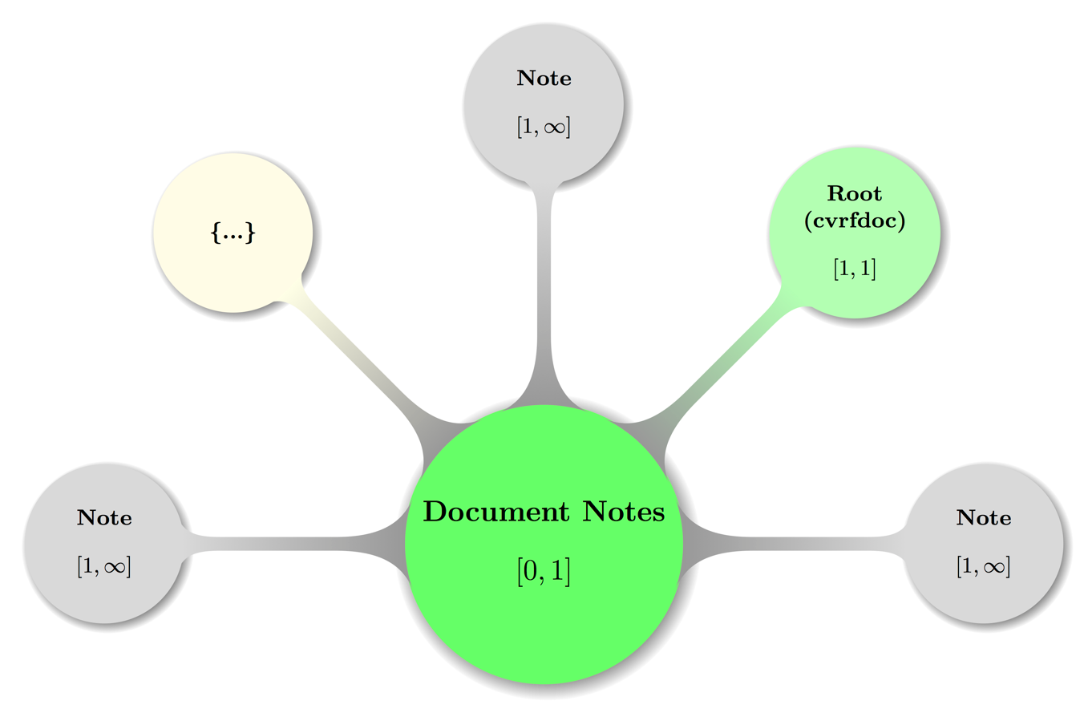

Figure 5: Visual presentation of abstract but topologically valid Document Notes instance.

Again, some decent coloring has been applied to above graph to balance visual hints with accessibility. The mathematical closed interval notation has been used to annotate the minimum and maximum occurrences of elements, where the infinity symbol (∞) translates to the term unbounded in XML lingo.

The node carrying an ellipsis (…) shall hint at possible further **Note** elements.

Example

See example in section 4.5.1

### Document Notes – Note

cvrf:DocumentNotes / cvrf:Note

**Data Type:** string  
**Range:** unrestricted  
**Minimum Occurrences:** 0  
**Maximum Occurrences:** unbounded  
**Parent:** Identification

Theelementcvrf:Noteis a place to put all manner of text blobs related to the document as a whole. It can be a concise summary of the overall document or a more compartmentalized and area-specific textual discussion. Depending on the need, there can be zero, one, or several **Note** elements in a given CSAF CVRF document.

The note should contain a compartmentalized textual discussion constrained by its *Type* attribute. *Type* can be one of the following:

* **General**: A general, high-level note (Title may have more information).
* **Details**: A low-level detailed discussion (Title may have more information).
* **Description**: A description of something (Title may have more information).
* **Summary**: A summary of something (Title may have more information).
* **FAQ**: A list of frequently asked questions.
* **Legal Disclaimer**: Any possible legal discussion, including constraints, surrounding the document.
* **Other**: Something that doesn’t fit (Title should have more information).

Title and Audience are optional attributes to give human readers context around what they are about to read; Title should be a concise description of what is contained in the text, whereas Audience will indicate who is intended to read it.

For example, when *Type* is “General”, *Title* is “executive summary”, and *Audience* is “executives”, the note is a high-level overview designed for consumption by C-level decision makers. It should be brief and devoid of any technical details and jargon. On the other hand, when *Type* is “Details”, *Title* is “technical summary”, and *Audience* is “operational management and system administrators”, the note will be more detailed in nature and will contain more operational information.

Ordinal is a mandatory, locally significant value used to track notes inside a CVRF document at the root (document) level. It is provided to uniquely identify a Note. There should be one of these values for every Note inside Document Notes, and it is recommended that Ordinal should be instantiated as a monotonically increasing counter, indexed from 1. Each Ordinal that tracks a Note inside Document Notes is completely independent from an Ordinal tracking a Note inside Vulnerability/Notes.

Example

Example 29:

<DocumentNotes>

<Note Type="General" Ordinal="1" Title="Details" Audience="All">  
 These are some details about a CVRF document intended for all stakeholders.

</Note>  
</DocumentNotes>

## Document Distribution

cvrf:DocumentDistribution

**Data Type:** string  
**Range:** unrestricted  
**Minimum Occurrences:** 0  
**Maximum Occurrences:** 1  
**Parent:** Root

The optional elementcvrf:DocumentDistributionshould contain details about constraints, if any, for sharing the CSAF CVRF document with additional recipients. Constraints may include instructions on how to reproduce, share, copy, or otherwise distribute the document.

Example

Example 30:

<DocumentDistribution xml:lang="de">  
 Urheberrechtlich geschützt, 2017, Fiktive GmbH  
</DocumentDistribution>

Example 31:

<DocumentDistribution xml:lang="en">  
 Copyright © 2010 Red Hat, Inc. All rights reserved.  
</DocumentDistribution>

## Aggregate Severity

cvrf:AggregateSeverity

**Data Type:** string  
**Range:** unrestricted  
**Minimum Occurrences:** 0  
**Maximum Occurrences:** 1  
**Parent:** Root  
**Children:** Contact Details, Issuing Authority  
**Attribute:** Namespace  
**Attribute Data Type:** anyURI  
**Attribute Range:** unrestricted  
**Attribute Required:** no

Theoptionalelementcvrf:AggregateSeverity is a container that is provided by the document producer to convey the urgency and criticality with which the vulnerability or vulnerabilities should be addressed. It is a document-level metric and applied to the document as a whole—not any specific vulnerability. The range of values in this field is defined according to the document producer's policies and procedures. These values can be understood only in the context of the document producer's stated practices. Therefore, the values may vary widely depending on the source of the document. The field is independent of—and in addition to—any other standard metric for determining the impact or severity of a given vulnerability (such as CVSS).

If one exists, the attribute Namespace should contain a URL pointing to the namespace so referenced.

Example

Example 32:

<AggregateSeverity Namespace="https://example.com/se/c/">Important</AggregateSeverity>

## Document References

cvrf:DocumentReferences

**Data Type:** container  
**Minimum Occurrences:** 0  
**Maximum Occurrences:** 1  
**Parent:** Root  
**Children:** Reference

Theoptionalelementcvrf:DocumentReferencesis a container that should include references to any conferences, papers, advisories, and other resources that are related and considered to be of value to the document consumer. For every **Document References** container, there must be at least one **Reference** element, and each **Reference** element must contain one **URL** and one **Description.**

Example

See example in section 4.8.1.2

### Document References – Reference

cvrf:DocumentReferences / cvrf:Reference

**Data Type:** container  
**Minimum Occurrences:** 1  
**Maximum Occurrences:** unbounded  
**Parent:** Document References  
**Children:** URL, Description  
**Attribute:** Type  
**Attribute Data Type:** enumerated list  
**Attribute Required:** yes  
**Attribute Default Value:** External

Theelementcvrf:Referencerefers to resources related to the overall CVRF document. These may include a plaintext or HTML version of the advisory or other related documentation, such as white papers or mitigation documentation.

The *Type* attribute denotes the type of the document reference relative to the given document. The follow types are available:

* **External:** The default value indicates the reference is external to the document.
* **Self**: This indicates the related document is actually a direct reference to itself

Example

See example in section 4.8.1.2

#### Document References – Reference – URL

cvrf:DocumentReferences / cvrf:Reference / cvrf:URL

**Data Type:** anyURI  
**Range:** unrestricted  
**Minimum Occurrences:** 1  
**Maximum Occurrences:** 1  
**Parent:** Reference

Theelementcvrf:URLin this container is the fixed URL or location of the reference.

Example

See example in section 4.8.1.2

#### Document References – Reference – Description

cvrf:DocumentReferences / cvrf:Reference / cvrf:Description

**Data Type:** string  
**Range:** unrestricted  
**Minimum Occurrences:** 1  
**Maximum Occurrences:** 1  
**Parent:** Reference

Theelementcvrf:Descriptionholds a descriptive title or the name of the reference.

Example

Example 33:

<References>  
 <Reference Type="External">

<URL>http://example.com/bar/</URL>

<Description xml:lang="fr">C'est un test de référence</Description>  
 </Reference>  
</References>

## Acknowledgements

cvrf:Acknowledgements

**Data Type:** container  
**Minimum Occurrences:** 1  
**Maximum Occurrences:** 1  
**Parent:** Root  
**Children:** Acknowledgement

Theoptionalelementcvrf:Acknowledgementsis a container holds one or more **Acknowledgment** containers, which contain recognition of external parties.

Visual Overview

Map of some valid **Acknowledgements** configuration including the parent node (**Root**) — again with the node labeled {…} indicating further possible **Acknowledgement** subtrees:

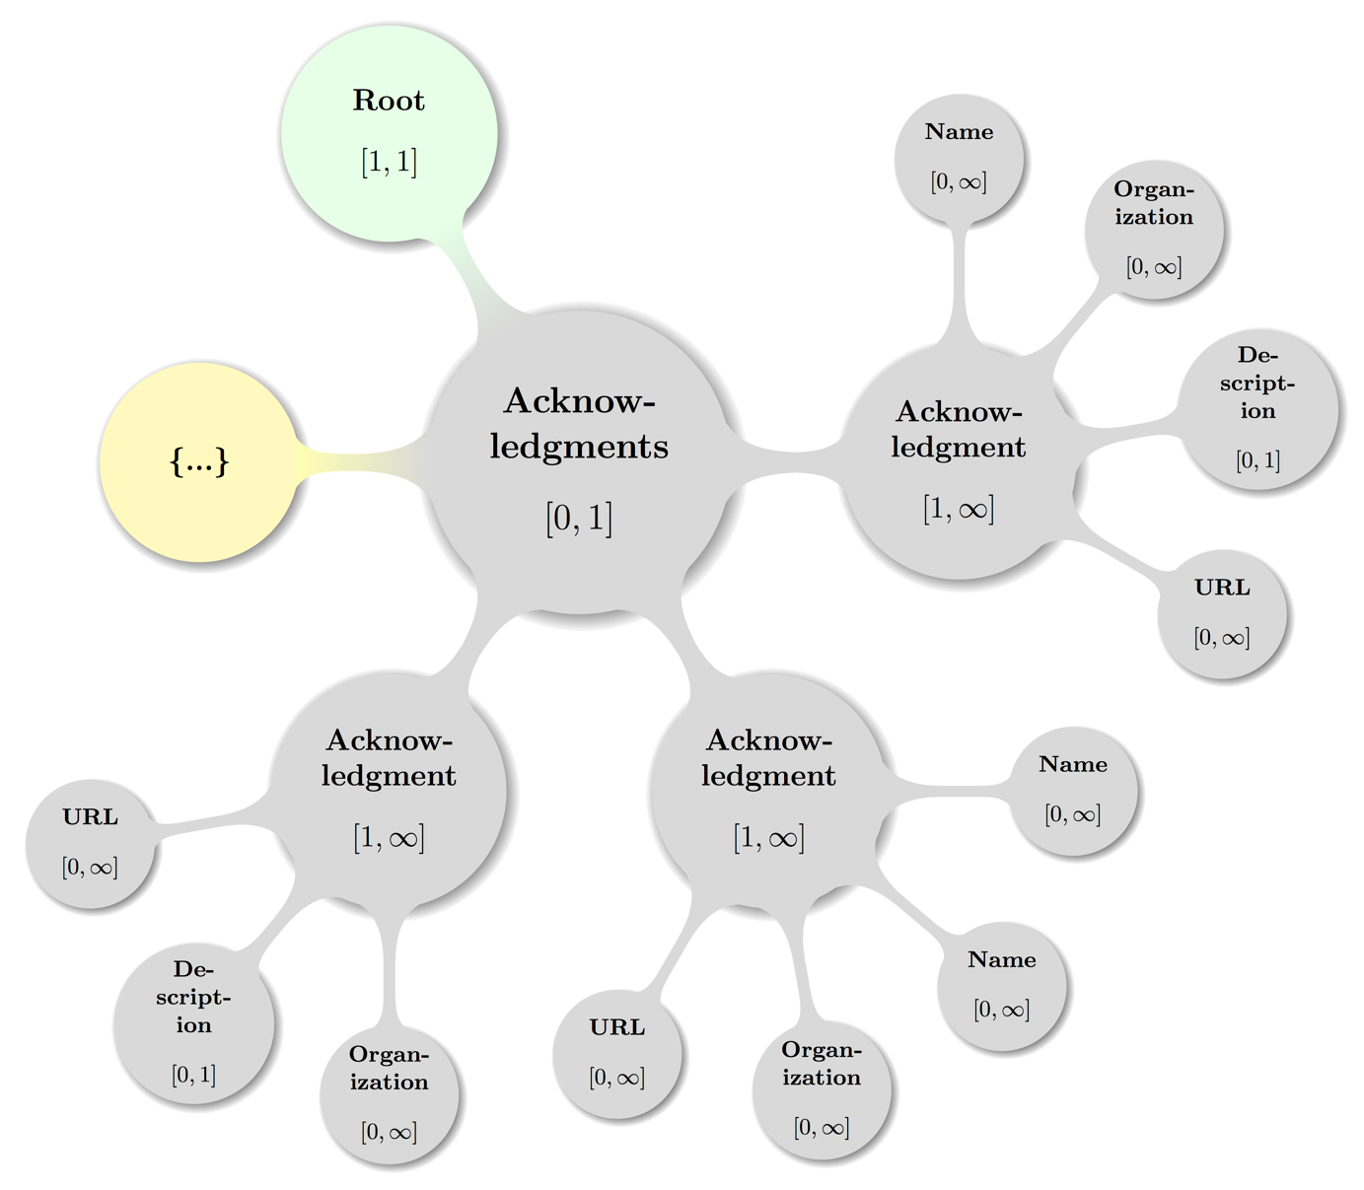

Figure 6: Visual presentation of abstract but topologically valid **Acknowledgements** configuration. This is the direct cvrf:cvrfdoc child element. For display of the vulnerability **Acknowledgements** container cf. section 6.15).

Example

See example in section 4.9.1.4

### Acknowledgements – Acknowledgement

cvrf:Acknowledgements / cvrf:Acknowledgement

**Data Type:** container  
**Minimum Occurrences:** 1  
**Maximum Occurrences:** unbounded  
**Parent:** Acknowledgements  
**Children:** Name, Organization, Description, URL

Theelementcvrf:Acknowledgementcontains recognition of external parties that reported noncritical/low- severity security issues or provided information, observations, or suggestions that contributed to improved security or improved documentation in future releases of the document producer's products. This may also contain recognition to external parties that contributed toward producing this document.

An acknowledgment container may contain four different types of child elements: **Name**, **Organization**, **Description**, and **URL**. All are described in the subsections below.

Example

See example in section 4.9.1.4

#### Acknowledgements – Acknowledgement – Name

cvrf:Acknowledgements / cvrf:Acknowledgement / cvrf:Name

**Data Type:** string  
**Range:** unrestricted  
**Minimum Occurrences:** 0  
**Maximum Occurrences:** unbounded  
**Parent:** Acknowledgement

Theelementcvrf:Nameshould contain the name of the party being acknowledged.

Example

See example in section 4.9.1.4

#### Acknowledgements – Acknowledgement – Organization

cvrf:Acknowledgements / cvrf:Acknowledgement / cvrf:Organization

**Data Type:** string  
**Range:** unrestricted  
**Minimum Occurrences:** 0  
**Maximum Occurrences:** 1  
**Parent:** Acknowledgement

Theelementcvrf:Organizationshould contain the organization of the party or if the **Name** is omitted, the organization itself that is being acknowledged.

Example

See example in section 4.9.1.4

#### Acknowledgements – Acknowledgement – Description

cvrf:Acknowledgements / cvrf:Acknowledgement / cvrf:Description

**Data Type:** string  
**Range:** unrestricted  
**Minimum Occurrences:** 0  
**Maximum Occurrences:** unbounded  
**Parent:** Acknowledgement

Theelementcvrf:Descriptioncan contain any contextual details the document producers wish to make known about the acknowledgment or acknowledged parties.

If attributing to multiple organizations, each contributor should be grouped with that **Organization** within a single **Acknowledgment** container. An **Organization**-specific acknowledgment may be added within each **Acknowledgment** container using the **Description** element. If an overall general or aggregate acknowledgment is to be added, an **Acknowledgment** container that contains a single **Description** element may be used.

Example

See example in section 4.9.1.4

#### Acknowledgements – Acknowledgement – URL

cvrf:Acknowledgements / cvrf:Acknowledgement / cvrf:URL

**Data Type:** anyURI  
**Range:** unrestricted  
**Minimum Occurrences:** 0  
**Maximum Occurrences:** unbounded  
**Parent:** Acknowledgement

Theelementcvrf:URL is the optional URL to the person, place, or thing being acknowledged.

Example

Example 34:

<Acknowledgments>

<Acknowledgment>  
 <Name>Johann Sebastian Bach</Name>

<Organization>Security Fugue LLC</Organization>  
 <Description>First analysis of Coordinated Multi-Stream Attack (CMSA)</Description>  
 <URL>https://secure-fugue.example.com/team/~jsb</URL>

</Acknowledgment>  
</Acknowledgments>

# Product Tree Schema Elements

Product information in CSAF CVRF is modeled as zero or one top-level Product Tree element instance of prod:ProductTree (defined in the product tree schema file within the prod namespace).

The following 4 second-level elements are and MUST appear in the order listed if given as elements of the top-level element Product Tree: [CSAF-5-1]

1. Branch: prod:Branch
2. Full Product Name prod:FullProductName
3. Relationship: prod:Relatinship
4. Product Groups: prod:ProductGroups

The remaining sub sections will describe the above 5 first and second level elements together with their children and grandchildren, constraints on them as well as state recommendations and examples.

To avoid duplication of data and accommodate for the many possible complex relationships among real world products, the 4 above named elements maybe nested deeply (e.g. a **Branch** of a **Branch** ...) or are clearly useful in many places like the **Full Product Name**.

The sub sections introducing **Branch, Relationship**, and **Product Groups** try to further offer such topological usage info to aid the reader in creating or navigating the graph that can be spanned by instances of a **Product Tree**.

As a service to the reader otherwise commonly used acronyms used in the rest of this section (or found in the XML schema source files are expanded here and as understood in the context of CVRF (for more details please cf. the respective sub sections below):

* CPE: Common Platform Enumeration (cf. [CPE23-N], [CPE23-M], [CPE23-D], and [CPE23-A])
* CVSS: Common Vulnerability Scoring System (cf. [CVSS3] preferred, [CVSS2] deprecated)
* SCAP: Security Content Automation Protocol (cf. [SCAP12])

## Product Tree

prod:ProductTree

**Data Type:** container  
**Minimum Occurrences:** 0  
**Maximum Occurrences:** 1  
**Parent:** Root  
**Children:** Branch, Full Product Name, Relationship

The optional elementprod:ProductTreeis a container for all fully qualified product names that can be referenced elsewhere in the document (specifically when describing the products that are affected by a vulnerability using the **Product Statuses**, **Threats**, **CVSS Score Sets**, and **Remediation** containers). The **Product Tree** can have as many branches as needed, but each endpoint of the tree must be terminated with a **Full Product Name** element, which represents a product that can be referenced elsewhere.

This structure is a major change from CVRF 1.0, where affected products were direct child elements of **Vulnerability**; the change was necessary to meet the vastly different requirements of various organizations in the way they document their products. Also, in situations where a CVRF document contains more than one vulnerability, a separate product repository at the document level reduces the need to duplicate all product entries in each vulnerability.

The **Product Tree** can be kept simple (flat) or made more detailed (branched out). It also supports concatenating products to describe relationships, such as components contained in a product or products installed on other products.

**Flat:**In the simplest case, a flat **Product Tree** would contain one or more **Full Product Name** elements at the root level, one for each product that needs to be described.

**Branched:**In a more detailed **Product Tree**, the root element would contain one or more **Branch** elements at the root level, one for each class/type/category of product, each of which again contains one or more **Branch** elements until all desired categories and subcategories are described to the satisfaction of the document issuer. Then each open **Branch** element is terminated with the actual product item in the form of a **Full Product Name** element.

**Concatenated:**No matter whether a flat or branched structure is chosen, you may need to be able to describe the combination of two **Full Product Name** elements, such as when a product is only vulnerable when installed together with another, or to describe operating system components. To do that, a **Relationship** element is inserted at the root of the **Product Tree**, with attributes establishing a link between two existing **Full Product Name** elements, allowing the document producer to define a combination of two products that form a new **Full Product Name** entry.

**Grouped:**Once **Full Product Name** elements are defined, they may be freely added to logical groups, which may then be used to refer to a group of products. Given that it is possible for a product to be a member of more than one logical group, some areas of the CVRF document may not allow references to product groups to avoid ambiguity.

Example

Example 35:

<prod:ProductTree>

<prod:Branch Name="Vendorix" Type="Vendor">  
 <prod:Branch Name="... Appliances" Type="Product Name">

<prod:Branch Name="1.0" Type="Product Version">

<prod:Branch Name=".0" Type="Service Pack">  
 <prod:FullProductName ProductID="CVRFPID-223152">

... AppY 1.0.0  
 </prod:FullProductName>

</prod:Branch>

<prod:Branch Name="(2)" Type="Service Pack">  
 <prod:FullProductName ProductID="CVRFPID-223153">

... AppY 1.0(2)  
 </prod:FullProductName>

</prod:Branch>

</prod:Branch>

<prod:Branch Name="1.1" Type="Product Version">  
 <prod:Branch Name=".0" Type="Service Pack">

<prod:FullProductName ProductID="CVRFPID-223155">

... AppY 1.1.0  
 </prod:FullProductName>

</prod:Branch>  
 <prod:Branch Name="(1)" Type="Service Pack">

<prod:FullProductName ProductID="CVRFPID-223156">  
 ... AppY 1.1(1)  
 </prod:FullProductName>

</prod:Branch>

</prod:Branch>  
 </prod:Branch>

</prod:Branch>

</prod:ProductTree>

Visual Overview

Map of **Product Tree** including the parent node (**Document**) in some valid configuration spanning multiple sub trees:

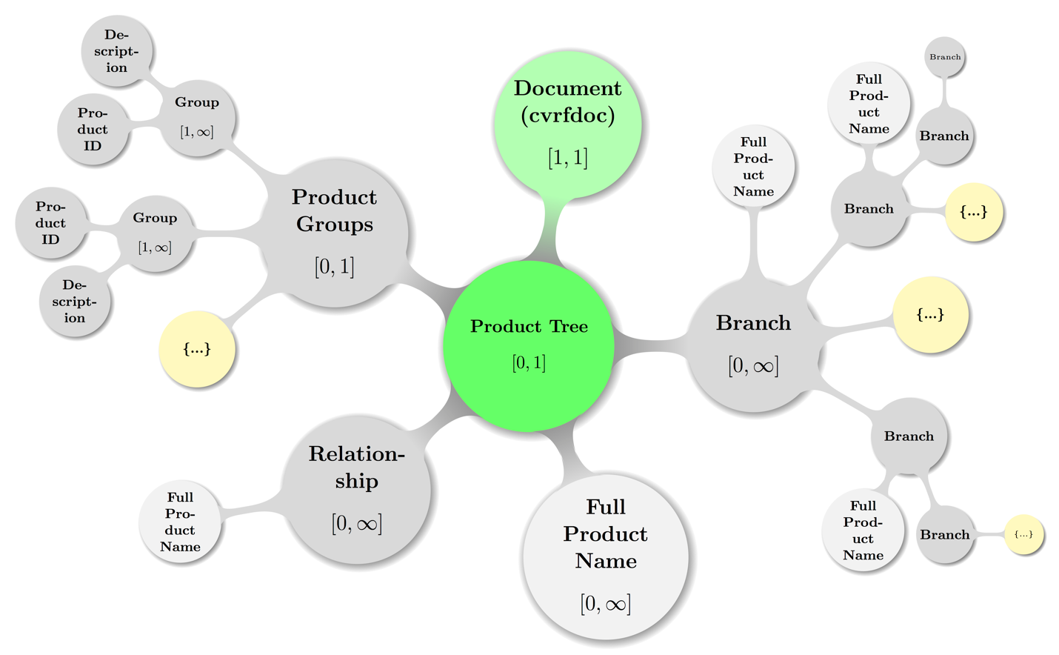

Figure 7: Visual presentation of abstract but topologically valid Product Tree instance.

Again, some decent coloring has been applied to above graph to balance visual hints with accessibility. The mathematical closed interval notation has been used to annotate the minimum and maximum occurrences of elements, where the infinity symbol (∞) translates to the term unbounded in XML lingo.

The pale gray color of the **Full Product Name** representative nodes shall indicate that they are more used like labels all over the topology. The nodes carrying an ellipsis (…) shall hint at possible further deep nesting of the sub trees where they are attached.

### Product Tree – Branch

prod:ProductTree / prod:Branch

**Data Type:** choice  
**Minimum Occurrences:** 0  
**Maximum Occurrences:** unbounded  
**Parent:** Product Tree, Branch  
**Children:** Branch, Full Product Name  
**Attribute:** Name, Type  
**Attribute Data Type:** string, enumerated list  
**Attribute Required:** yes, yes

The prod:Branchelement is a choice element. A choice element behaves as a regular container that can have different child elements, but with the difference that only exactly one child element can be chosen. It is similar in concept to the “union” programming construct in which one variable can have one of several different predefined data types.

The **Branch** element contains a *Type*-*Name* pair as mandatory attributes to describe the characteristics of the current **Branch**. *Type* will describe the category of the branch in question. A full universe of values for version 1.2 is shown below.

Branch *Type*s:

* **Vendor**: The name of the vendor or manufacturer that makes the product
* **Product Family**: The product family that the product falls into
* **Product Name**: The name of the product
* **Product Version**: The product version, can be numeric or some other descriptor
* **Patch Level:** The patch level of the product
* **Service Pack**: The service pack of the product
* **Architecture**: The architecture for which the product is intended
* **Language**: The language of the product
* **Legacy**: A nonspecific legacy entry
* **Specification**: A specification such as a standard, best common practice, etc.

*Name* will contain the canonical descriptor or “friendly name” of the branch.

As for the child elements, each **Branch** can have either one of the following children:

* One **Full Product Name**. A single child element terminates the branch by describing a final product entry (described below).
* More **Branches**. Multiple additional **Branch** containers, which on their own can either terminate in a single **Full Product Name** element or yet more **Branch** containers.

Example

Example 36: Nesting of **Branches** in a **Branch** subtree:

<prod:Branch Type="Vendor" Name="Microsoft">

<prod:Branch Type="Product Family" Name="Windows">  
 <prod:Branch Type="Product Name" Name="Vista">  
 <prod:Branch Type="Service Pack" Name="1">

<prod:FullProductName ProductID="CVRFPID-0001">  
 Microsoft Windows Vista Service Pack 1  
 </prod:FullProductName>  
 </prod:Branch>  
 <prod:Branch Type="Service Pack" Name="2">  
 <prod:FullProductName ProductID="CVRFPID-0002">  
 Microsoft Windows Vista Service Pack 2  
 </prod:FullProductName>

</prod:Branch>  
 </prod:Branch>

</prod:Branch>

<prod:Branch Type="Product Family" Name="Office">  
 <prod:Branch Type="Product Name" Name="Word 2010">  
 <prod:Branch Type="Service Pack" Name="0">  
 <prod:Branch Type="Architecture" Name="x86">  
 <prod:FullProductName ProductID="CVRFPID-0003">  
 Microsoft Word 2010 (32-bit editions)  
 </prod:FullProductName>

</prod:Branch>

</prod:Branch>  
 </prod:Branch>

</prod:Branch>

</prod:Branch>

A more visual display of the same structure from above example is shown in the figure below (Figure 8: Graphical display of a Product Tree - Branch combination).

Visual Overview

Map of **Branch** sub tree from above example of nested Branches including the parent node (**Product Tree** left out in XML source code example) with some textual hints to map the topologies:

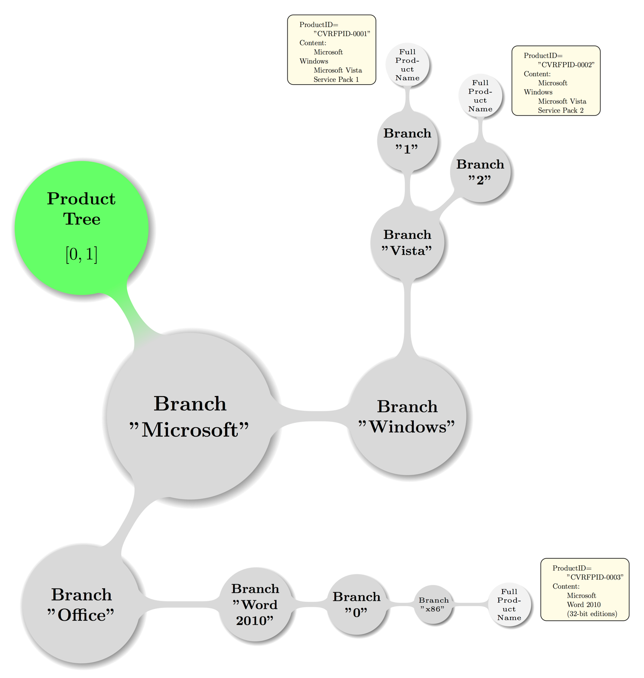

Figure 8: Graphical display of a Product Tree - Branch combination

### Product Tree – Full Product Name

prod:ProductTree / prod:FullProductName

**Data Type:** string  
**Range:** unrestricted  
**Minimum Occurrences:** 1  
**Maximum Occurrences:** unbounded  
**Parent:** Product Tree, Relationship, Branch  
**Attribute:** Product ID, CPE  
**Attribute Data Type:** token, CPE number or CPE URI  
**Attribute Required:** yes, no

The prod:FullProductNameelements define the endpoints of the **Product Tree** and occur directly at the root level, at the branch level, or as the result of a relationship between two products. The value of a **Full Product Name** element should be the product’s full canonical name, including version number and other attributes, as it would be used in a human-friendly document.

The Common Platform Enumeration (*CPE*) attribute refers to a method for naming platforms. The structure for CPE is described at http://cpe.mitre.org. The *CPE* can be either an integer (if MITRE has an entry for the platform in question) or a candidate string from the vendor if no MITRE entry yet exists.

The *Product ID* attribute is required to identify a **Full Product Name** so that it can be referred to from other parts in the document. There is no predefined or required format for the *Product ID* as long as it uniquely identifies a product in the context of the current document. Examples include incremental integers or Globally Unique Identifiers (GUIDs).

Examples

Example 37:

<FullProductName ProductID="CVRFPID-0004">

Microsoft Host Integration Server 2006 Service Pack 1  
</FullProductName>

Example 38:

<FullProductName ProductID="CVRFPID-0005">  
 Microsoft Office 2008 for Mac 12.3.1 Update  
</FullProductName>

### Product Tree – Relationship

prod:ProductTree / prod:Relationship

**Data Type:** container  
**Minimum Occurrences:** 0  
**Maximum Occurrences:** unbounded  
**Parent:** Product Tree  
**Children:** Full Product Name  
**Attribute:** Product Reference, Relationship Type,   
 Relates To Product Reference  
**Attribute Data Type:** token, enumerated list, token  
**Attribute Required:** yes, yes, yes

The prod:Relationshipelement establishes a link between two existing **Full Product Name** elements, allowing the document producer to define a combination of two products that form a new **Full Product Name** entry.

This situation arises when a product is vulnerable only when installed together with another, or to describe operating system components. As a **Relationship** connects two existing products with each other, there need to be at least two **Full Product Name** entries present in the **Product Tree** before a Relationship element can be created.

**Relationship** elements live at the root of a **Product Tree**, and they have three mandatory attributes: *Product Reference* and *Relates To Product Reference* each contain the *Product ID* token for the two products that will form the relationship, and the *Type* attribute defines how the products are related.

Consider two previously constructed products with *Product IDs* CVRFPID-0001 and CVRFPID- 0002. CVRF v1.1 supports the following **Relationship** *Type* values:

* **Default Component Of**: CVRFPID-0001 is a default component of CVRFPID-0002
* **Optional Component Of**: CVRFPID-0001 is an optional component of CVRFPID-0002
* **External Component Of**: CVRFPID-0001 is an external component of CVRFPID-0002
* **Installed On**: CVRFPID-0001 is installed on CVRFPID-0002
* **Installed With**: CVRFPID-0001 is installed with CVRFPID-0002  Once a **Relationship** element has been created, it needs to be completed by adding one **Full Product Name** element as a child, typically using a combination of the two related product names as a value.

Examples

Example 39:

The first product is defined as:

<FullProductName ProductID="CVRFPID-0007">  
 Active Directory Lightweight Directory Service  
</FullProductName>

And the second product is defined as:

<FullProductName ProductID="CVRFPID-0008">  
 Windows Vista Service Pack 2  
</FullProductName>

And the relationship can then be defined as:

<Relationship ProductReference="CVRFPID-0007" RelationType="OptionalComponentOf"

RelatesToProductReference = "CVRFPID-0008">  
 <FullProductName ProductID=”CVRFPID-0009>

Active Directory Lightweight Directory Service as an optional component of   
 Windows Vista Service Pack 2

</FullProductName>  
</Relationship>

Example 40:

In another example, the first product is defined as:

<FullProductName ProductID="CVRFPID-0010">

Cisco AnyConnect Secure Mobility Client 2.3.185

</FullProductName>

And the second product is defined as:

<FullProductName ProductID="CVRFPID-0011">Microsoft Windows</FullProductName>

And the relationship can then be defined as:

<Relationship ProductReference="CVRFPID-0010" RelationType="InstalledOn"

RelatesToProductReference="CVRFPID-0011">  
 <FullProductName ProductID=”CVRFPID-0012>

Cisco AnyConnect Secure Mobility Client 2.3.185 when installed on Microsoft Windows

</FullProductName>  
</Relationship>

### Product Tree – Product Groups

prod:ProductTree / prod:ProductGroups

**Data Type:** container  
**Minimum Occurrences:** 0  
**Maximum Occurrences:** 1  
**Parent:** Product Tree  
**Children:** Group

The optional element prod:ProductGroupsis a container, that defines whether **Full Product Name** elements in the product tree will be grouped into logical groups. If the container is present, at least one Group must be defined.

If groups are defined, products can be referred to using the Group ID attribute in many other parts of the document, rather than repeatedly having to list all members individually.

Whether groups are defined or not, the ability to reference each product individually in other parts of the document is not affected. In fact, the creator of a document can choose to use either direct product references or group references.

Note:

Given that a single product can be a member of more than one group, some areas of the CVRF document may not allow product references by group to avoid ambiguity.

Example

Example 41:

We create two groups, CVRFGID-0001 and CVRFGID-0002. Both groups have four members, and ProductID CVRFPID-0001 is a member of both groups:

<ProductGroups>

<Group GroupID="CVRFGID-0001">  
 <ProductID>CVRFPID-0001</ProductID>  
 <ProductID>CVRFPID-0002</ProductID>  
 <ProductID>CVRFPID-0003</ProductID>  
 <ProductID>CVRFPID-0004</ProductID>

</Group>  
 <Group GroupID="CVRFGID-0002">

<ProductID>CVRFPID-0001</ProductID>  
 <ProductID>CVRFPID-0010</ProductID>  
 <ProductID>CVRFPID-0011</ProductID>  
 <ProductID>CVRFPID-0099</ProductID>

</Group>  
</ProductGroups>

Visual Overview

Map of fictitious sample **Product Groups** sub tree including the parent node (**Product Tree**) with the node labeled {…} indicating further possible **Group** subtrees:

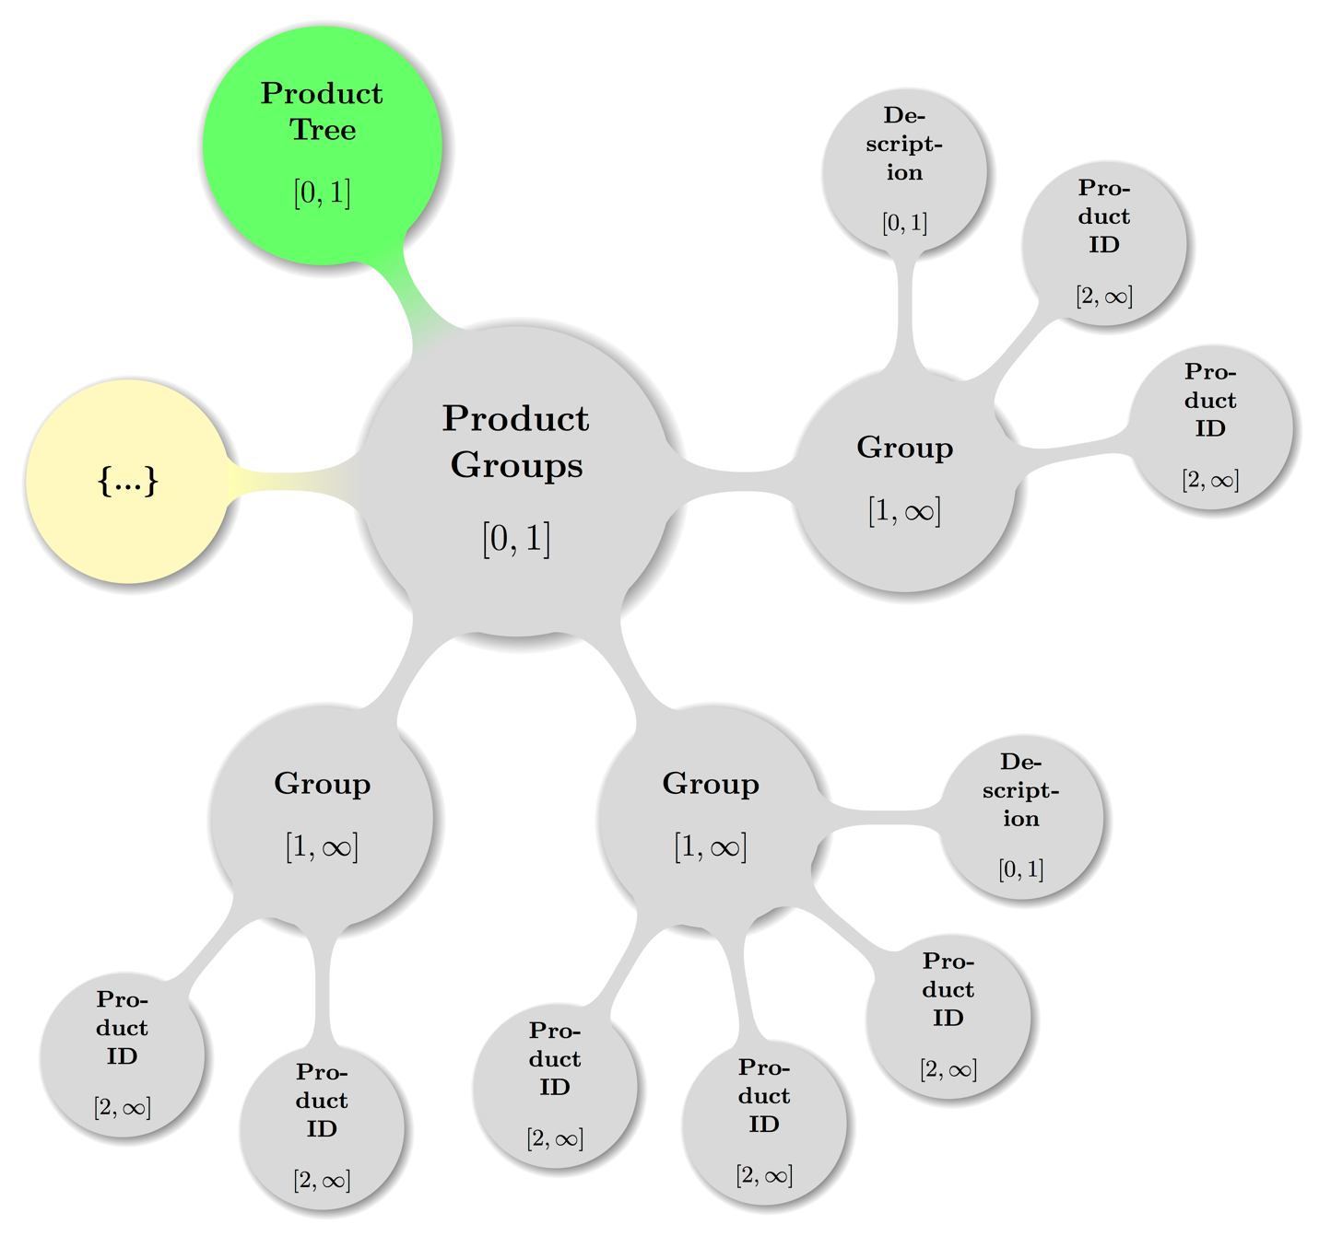Figure 9: Map of a Product Groups topology

#### Product Tree – Product Groups – Group

prod:ProductTree / prod:ProductGroups / prod:Group

**Data Type:** container  
**Minimum Occurrences:** 1  
**Maximum Occurrences:** unbounded  
**Parent:** Product Groups  
**Children:** Description, Product ID  
**Attribute:** Group ID  
**Attribute Data Type:** token   
**Attribute Required:** yes

The element prod:Groupis a container, that defines a new logical group of products that can then be referred to in other parts of the document to address a group of products with a single identifier. **Group** members are defined by adding one **Product ID** element for each member of the group.

The *Group ID* attribute is required to identify a **Group** so that it can be referred to from other parts in the document. There is no predefined or required format for the *Group ID* as long as it uniquely identifies a group in the context of the current document. Examples include incremental integers or GUIDs.

Example

See examples in sections 5.1.4.1.1 and 5.1.4.1.2

##### Product Tree – Product Groups – Group – Description

prod:ProductTree / prod:ProductGroups / prod:Group / prod:Description

**Data Type:** string  
**Range:** unrestricted  
**Minimum Occurrences:** 0  
**Maximum Occurrences:** 1  
**Parent:** Group

The optional element prod:Descriptionis a short, optional description of the group.

Example

Example 42:

<ProductGroups>

<Group GroupID="CVRFGID-0001">  
 <Description>The x64 versions of the operating system.</Description>  
 <ProductID>CVRFPID-0001</ProductID>  
 <ProductID>CVRFPID-0002</ProductID>  
 <ProductID>CVRFPID-0003</ProductID>  
 <ProductID>CVRFPID-0004</ProductID>

</Group>  
</ProductGroups>

##### Product Tree – Product Groups – Group – Product ID

prod:ProductTree / prod:ProductGroups / prod:Group / prod:Description

**Data Type:** token  
**Minimum Occurrences:** 2  
**Maximum Occurrences:** unbounded  
**Parent:** Group

The element prod:ProductIDdefines a member of a group by referring to the unique *Product ID* attribute of a **Full Product Name** element.

Examples

Example 43:

If the two products “Microsoft Windows Vista Service Pack 1” and “Microsoft Windows Vista Service Pack 2” have been defined in the product tree as follows:

<FullProductName ProductID="CVRFPID-0001">  
 Microsoft Windows Vista Service Pack 1  
</FullProductName>  
<FullProductName ProductID="CVRFPID-0002">  
 Microsoft Windows Vista Service Pack 2  
</FullProductName>

They can both be made a member of the same group with Group ID “GRP-0001”:

<ProductGroups>  
 <Group GroupID="GRP-0001">

<ProductID>CVRFPID-0001</ProductID>

<ProductID>CVRFPID-0002</ProductID>  
 </Group>

</ProductGroups>

Later in the document, both products can be referenced together using the Group ID:

<Remediations>  
 <Remediation Type="Vendor Fix">

<Description>Security Update for Windows Vista</Description>

<GroupID>GRP-0001</GroupID>  
 </Remediation>

</Remediations>

The ability to reference both products individually will also be maintained (and in some cases required):

<Remediations>  
 <Remediation Type="Vendor Fix">

<Description>Security Update for Windows Vista</Description>  
 <ProductID>CVRFPID-0001</ProductID>  
 <ProductID>CVRFPID-0002</ProductID>

</Remediation>  
</Remediations>

# Vulnerability Schema Elements

Vulnerability information in CSAF CVRF is modeled as zero or more top-level Vulnerability element instances of vuln:Vulnerability (defined in the vulnerability schema file within the vuln namespace).

The following listed 14 second-level elements MUST appear in the order listed if given as elements of the top-level element Vulnerability: [CSAF-6-1]

1. Title: vuln:Title
2. ID: vuln:ID
3. Notes: vuln:Notes
4. Discovery Date: vuln:DiscoveryDate
5. Release Date: vuln:ReleaseDate
6. Involvements: vuln:Involvements
7. CVE: vuln:CVE
8. CWE: vuln:CWE
9. Product Statuses: vuln:ProductStatuses
10. Threats: vuln:Threats
11. CVSS Score Sets: vuln:CVSSScoreSets
12. Remediations: vuln:Remediations
13. References: vuln:References
14. Acknowledgements: vuln:Acknowledgements

The remaining sub sections will describe the above 15 first and second level elements together with their children and grandchildren, constraints on them as well as state recommendations and examples.

As a service to the reader otherwise commonly used acronyms stated above are expanded here and as understood in the context of CVRF (for more details please cf. the respective sub sections below):

* CVE: Common Vulnerabilities and Exposures
* CVSS: Common Vulnerability Scoring System (cf. [CVSS3] preferred, [CVSS2] deprecated)
* CWE: Common Weakness Enumeration

## Vulnerability

vuln:Vulnerability

**Data Type:** container  
**Minimum Occurrences:** 0  
**Maximum Occurrences:** unbounded  
**Parent:** Root  
**Children:** Title, ID, Involvements, Notes, Discovery Date, Release Date, CVE,  
 CWE, Threats, CVSS Score Sets, Remediation, Product Statuses,   
 Acknowledgments, References   
**Attribute:** Ordinal  
**Attribute Data Type:** positiveInteger  
**Attribute Required:** yes  
**Attribute Default Value:** 1

The optional elementvuln:Vulnerabilityis a container for the aggregation of all fields that are related to a single vulnerability in the document. There may be zero, one, or many vulnerabilities in a single CVRF document.

*Ordinal* is a locally significant value used to track vulnerabilities inside a CVRF document. It is provided to enable specific vulnerabilities to be referenced from elsewhere in the document (or even outside the namespace of a document provided that a unique **Document Title** and **Revision** information are provided). There should be one of these values for every **Vulnerability** container in a document, and it is recommended that *Ordinal* should be instantiated as a monotonically increasing counter, indexed from 1.

Example

Example 44:

<Vulnerability Ordinal="1"   
 xmlns="http://docs.oasis-open.org/csaf/ns/csaf-cvrf/v1.2/vuln">  
 <!-- ... All children optional, so this is valid, albeit otherwise useless -->

</Vulnerability>

Visual Overview

Map of **Vulnerability** element including the parent node (**Document**) in some valid configuration spanning multiple sub trees:

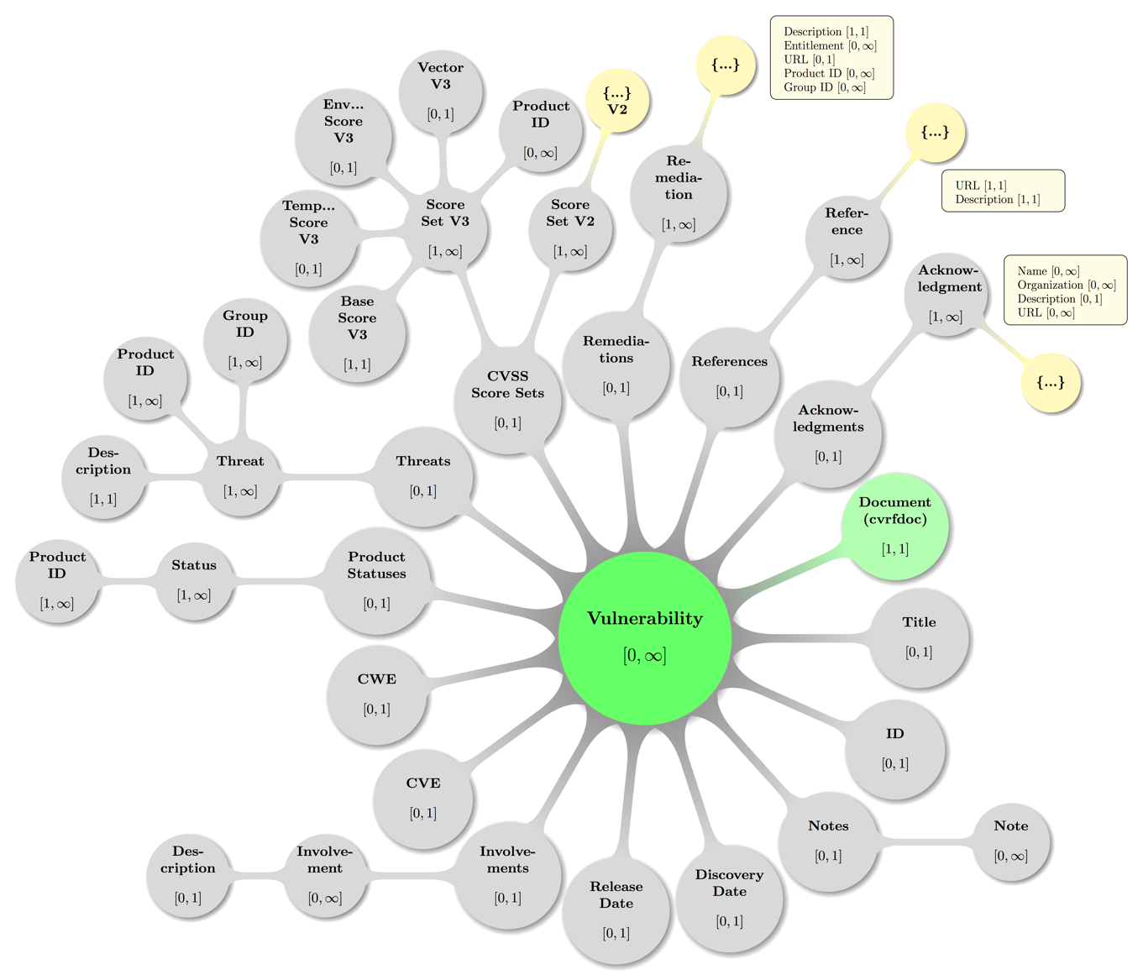

Figure 10: Visual presentation of abstract but topologically valid Vulnerability instance.

As before, some decent coloring has been applied to above graph as usual to balance visual hints with accessibility. Also, the mathematical closed interval notation has been used to annotate the minimum and maximum occurrences of elements, where the infinity symbol (∞) translates to the term unbounded in XML lingo.

The nodes carrying an ellipsis (…) here are to be read combined with the rounded edge rectangles, as the latter list the represented leaf elements that did not well fit into the picture.

## Vulnerability – Title

vuln:Vulnerability / vuln:Title

**Data Type:** string  
**Range:** unrestricted  
**Minimum Occurrences:** 0  
**Maximum Occurrences:** 1  
**Parent:** Vulnerability

The optional element vuln:Titlegives the document producer the ability to apply a canonical name or title to the vulnerability. To avoid confusion, it is recommended that, if employed, this element commensurately match the nomenclature used by any numbering or cataloging systems references elsewhere, such as the **Document Title** or **CVE**.

Examples

Example 45:

<Title>February 2011 TelePresence Vulnerability Bundle</Title>

## Vulnerability – ID

vuln:Vulnerability / vuln:ID

**Data Type:** token  
**Range:** unrestricted  
**Minimum Occurrences:** 0  
**Maximum Occurrences:** 1  
**Parent:** Vulnerability  
**Attribute:** System Name  
**Attribute Data Type:** string   
**Attribute Required:** yes

The optional element vuln:IDgives the document producer a place to publish a unique label or tracking ID for the vulnerability (if such information exists).

General examples may include an identifier from a vulnerability tracking system that is available to customers, such as a Cisco bug ID, an ID from a Bugzilla system, or an ID from a public vulnerability database such as the X-Force Database. The **ID** may be a vendor-specific value.

The **ID** should not be used for CVE tracking numbers (MITRE standard Common Vulnerabilities and Exposures). CVE numbers should be specified using the separate CVE element. Values are tokenized and can be alphanumeric.

The attribute *System Name* indicates the name of the vulnerability tracking or numbering system that this **ID** comes from. Every **ID** value should have exactly one *System Name*. It is helpful if document producers use unique and consistent system names.

Example

Example 46:

<vuln:Vulnerability>

<vuln:ID SystemName="Cisco Bug ID">CSCso66472</vuln:ID>

</vuln:Vulnerability>

## Vulnerability – Notes

vuln:Vulnerabilty / vuln:Notes

**Data Type:** container  
**Minimum Occurrences:** 0  
**Maximum Occurrences:** 1  
**Parent:** Vulnerability  
**Children:** Note

The optional elementvuln:Notesis a container that holds all vulnerability-level **Note** elements.

Example

See example in section 4.5.1

### Vulnerability – Notes – Note

vuln:Vulnerabilty / vuln:Notes / cvrf:Note

**Data Type:** string  
**Range:** unrestricted  
**Minimum Occurrences:** 1  
**Maximum Occurrences:** unbounded  
**Parent:** Vulnerability  
**Attribute:** Type, Ordinal, Title, Audience  
**Attribute Data Type:** enumerated list, positiveInteger, string, string   
**Attribute Required:** yes, yes, no, no

Theelementvuln:Noteis a place to put all manner of text blobs related to the vulnerability. Text should be limited to talking about the impacts, vectors, or caveats of this node and should not contain details to other vulnerabilities in the document. It is, however, acceptable to refer to a vulnerability that is not in the document for the purposes of pointing out a regression.

Akin to the **Document Notes** element, the note should contain a compartmentalized textual discussion constrained by its *Type* attribute. *Type* can be one of the following:

* **General:** A general, high-level note (*Title* may have more information).
* **Details:** A low-level detailed discussion (*Title* may have more information).
* **Description:** A description of something (*Title* may have more information).
* **Summary**: A summary of something (*Title* may have more information).
* **FAQ**: A list of frequently asked questions.
* **Legal Disclaimer**: Any possible legal discussion, including constraints, surrounding the vulnerability.
* **Other**: Something that doesn’t fit (*Title* should have more information).

*Title* and *Audience* are optional attributes to give human readers context around what they are about to read; *Title* should be a concise description of what is contained in the text, whereas *Audience* will indicate who is intended to read it.

*Ordinal* is a mandatory, locally significant value used to track notes inside a CVRF document at the vulnerability level. It is provided to uniquely identify a **Note**. There should be one of these values for every **Note** inside **Vulnerability/Notes** and it is recommended that *Ordinal* should be instantiated as a monotonically increasing counter, indexed from 1. Each *Ordinal* that tracks a **Note** inside **Vulnerability/Notes** is completely independent from an *Ordinal* tracking a **Note** inside **Document Notes**.

Example

Example 47:

<vuln:Notes>

<vuln:Note Type="General" Ordinal="1" Title="Details" Audience="All">  
 These are some details about a vulnerability intended for all stakeholders.

</vuln:Note>  
</vuln:Notes>

## Vulnerability – Discovery Date

vuln:Vulnerability / vuln:DiscoveryDate

**Data Type:** dateTime  
**Minimum Occurrences:** 0  
**Maximum Occurrences:** 1  
**Parent:** Vulnerability

The optional element vuln:DiscoveryDateholds the date the vulnerability was originally discovered. All dateTime values in CSAF CVRF require a date and a time (cf. section 2.2 Date and Time).

Example

Example 48:

<DiscoveryDate>2010-11-03T00:00:00Z</DiscoveryDate>

## Vulnerability – Release Date

vuln:Vulnerability / vuln:ReleaseDate

**Data Type:** dateTime  
**Minimum Occurrences:** 0  
**Maximum Occurrences:** 1  
**Parent:** Vulnerability

The optional element vuln:ReleaseDateholds the date the vulnerability was originally released into the wild. All dateTime values in CSAF CVRF require a date and a time (cf. section 2.2 Date and Time).

Example

Example 49:

<ReleaseDate>2010-11-16T00:00:00Z</ReleaseDate>

## Vulnerability – Involvements

vuln:Vulnerabilty / vuln:Involvements

**Data Type:** container  
**Minimum Occurrences:** 0  
**Maximum Occurrences:** 1  
**Parent:** Vulnerability  
**Children:** Involvement

The optional elementvuln:Involvementsis a container that holds one or more **Involvement** containers, which allow the document producers (or third party) to comment on their level of involvement in the vulnerability identification, scoping, and remediation process. Because there can be multiple Involvements containers, multiple parties can comment on their levels of involvement.

Example

See example in section 6.7.1.1

### Vulnerability – Involvements – Involvement

vuln:Vulnerabilty / vuln:Involvements / vuln:Involvement

**Data Type:** container  
**Minimum Occurrences:** 1  
**Maximum Occurrences:** unbounded  
**Parent:** Involvements  
**Children:** Description  
**Attribute:** Party, Status  
**Attribute Data Type:** enumerated list, enumerated list   
**Attribute Range:** {Vendor, Discoverer, Coordinator, User, Other},   
 {Open, Disputed, In Progress, Completed, Contact Attempted,   
 Not Contacted}  
**Attribute Required:** yes, yes

Theelementvuln:Involvement is a container, thatallows the document producers to comment on their level of Involvement (or engagement) in the vulnerability identification, scoping, and remediation process.

The attribute *Party* indicates the type of the producer issuing the status. It is identical to the **Document Publisher** attribute *Type*. Most of the time, both attributes will be the same because document producers will issue an **Involvement** status on their own behalf. However, if the document producer wants to issue a status on behalf of a third party and use a different type from that used in **Document Publisher**, that use is allowed by the schema. If this is the case, **Description** should contain additional context regarding what is going on.

The attribute *Status* indicates the level of involvement of *Party*. The child **Description** (below) is an optional element used to give context about the

involvement or engagement of the *Party*. The final two status states, “Contact Attempted” and “Not Contacted,” are intended for use by

document producers other than vendors (such as research or coordinating entities).

Status types include:

* **Open:** This is the default status. It doesn’t indicate anything about the vulnerability remediation effort other than the fact that the vendor has acknowledged awareness of the vulnerability report. The use of this status by a vendor indicates that future updates from the vendor about the vulnerability are to be expected.
* **Disputed:** This status indicates that the vendor disputes the vulnerability report in its entirety. Vendors should indicate this status when they believe that a vulnerability report regarding their product is completely inaccurate (that there is no real underlying security vulnerability) or that the technical issue being reported has no security implications.
* **In Progress:** This status indicates that some hotfixes, permanent fixes, mitigations, workarounds, or patches may have been made available by the vendor, but more information or fixes may be released in the future. The use of this status by a vendor indicates that future information from the vendor about the vulnerability is to be expected.
* **Completed:** The vendor asserts that investigation of the vulnerability is complete. No additional information, fixes, or documentation from the vendor about the vulnerability should be expected to be released.
* **Contact Attempted:** The document producer attempted to contact the affected vendor.
* **Not Contacted:** The document producer has not attempted to make contact with the  affected vendor.

Each status is mutually exclusive—only one status is valid for a particular vulnerability at a particular time. As the vulnerability ages, a party’s involvement could move from state to state. However, in many cases, a document producer may choose not to issue CVRF documents at each state, or simply omit this element altogether. It is recommended, however, that vendors that issue CVRF documents indicating an open or in-progress **Involvement** should eventually expect to issue a document as Disputed or Completed.

Example

See example in section 6.7.1.1

#### Vulnerability – Involvements – Involvement – Description

vuln:Vulnerabilty / vuln:... / vuln:Involvement / vuln:Description

**Data Type:** string  
**Range:** unrestricted  
**Minimum Occurrences:** 0  
**Maximum Occurrences:** 1  
**Parent:** Involvement

The optional elementvuln:Descriptionwill contain a thorough human-readable discussion of the **Involvement**.

Examples

Example 50:

<Involvements>  
 <Involvement Party="Vendor" Status="In Progress">

<Description>

Cisco acknowledges that the IronPort Email Security Appliances (ESA) and Cisco  
 IronPort Security Management Appliances (SMA) contain a vulnerability that may   
 allow a remote, unauthenticated attacker to execute arbitrary code with elevated   
 privileges. A Mitigation is available.  
 </Description>

</Involvement>  
</Involvements>

Example 51:

<Involvements>

<Involvement Party="Researcher" Status="Contact Attempted">  
 <Description>

We emailed the vendor on February 14, 2012 when the vulnerability was first   
 discovered by our team.

</Description>

</Involvement>  
</Involvements>

Example 52:

<Involvements>  
 <Involvement Party="Vendor" Status="Completed"></Involvement>  
</Involvements>

## Vulnerability – CVE

vuln:Vulnerability / vuln:CVE

**Data Type:** token  
**Range:** unrestricted  
**Minimum Occurrences:** 0  
**Maximum Occurrences:** 1  
**Parent:** Vulnerability

The optional element vuln:CVEholds the MITRE standard Common Vulnerabilities and Exposures (CVE) tracking number for the vulnerability. CVE is a standard for vulnerability naming that provides improved tracking of vulnerabilities over time across different reporting sources. More information about CVE is available at http://cve.mitre.org/.

Example

Example 53:

<CVE>CVE-2010-3864</CVE>

## Vulnerability – CWE

vuln:Vulnerability / vuln:CWE

**Data Type:** token  
**Range:** unrestricted  
**Minimum Occurrences:** 0  
**Maximum Occurrences:** 1  
**Parent:** Vulnerability

The optional element vuln:CWEcontains the MITRE standard Common Weakness Enumeration (CWE). MITRE describes CWE in this way: “[CWE] is a formal list of software weakness types created to:

* Serve as a common language for describing software security weaknesses in architecture, design, or code.
* Serve as a standard measuring stick for software security tools targeting these weaknesses.
* Provide a common baseline standard for weakness identification, mitigation, and  prevention efforts.”

More information about CWE is available at http://cwe.mitre.org/.

Examples

Example 54:

<CWE ID="CWE-601">URL Redirection to Untrusted Site ('Open Redirect')</CWE>

Example 55:

<CWE ID="CWE-602">Client-Side Enforcement of Server-Side Security</CWE>

## Vulnerability – Product Statuses

vuln:Vulnerabilty / vuln:ProductStatuses

**Data Type:** container  
**Minimum Occurrences:** 0  
**Maximum Occurrences:** 1  
**Parent:** Vulnerability  
**Children:** Status

The optional elementvuln:ProductStatusesis a container that holds one or more **Status** containers, which will contain a subset of products chosen from **Product Tree** (see below). Each of the affected (and unaffected) products relating to the vulnerability will be referenced here, inside one or more **Status** containers.

Note there is a constraint in place to prevent a single product from being assigned two different (conflicting) **Status** elements within the scope of **Vulnerability**. Likewise, a **Status** child container cannot be tied to a **Product Group** due to the fact that a single product can be a member of more than one product group. Without this constraint, it would be possible to assign conflicting status information to one and the same product.

Example

See example in section 6.10.1.1

### Vulnerability – Product Statuses – Status

vuln:Vulnerabilty / vuln:ProductStatuses / vuln:Status

**Data Type:** container  
**Minimum Occurrences:** 1  
**Maximum Occurrences:** unbounded  
**Parent:** Product Statuses  
**Children:** Product ID  
**Attribute:** Type  
**Attribute Data Type:** enumerated list  **Attribute Required:** yes

Theelementvuln:Status contains one or more products as chosen from the **Product Tree**, and defines the status of this product in the mandatory *Status* attribute.

The *Type* attribute is an enumerated value that contains all the possible permutations of fixed, affected, and recommended versions of the products referenced inside the **Status** container. *Type* values include:

* **First Affected:** This is first version of the affected release known to be affected by the vulnerability.
* **Known Affected:** This version is known to be affected by the vulnerability.
* **Known Not Affected:** This version is known not to be affected by the vulnerability.
* **First Fixed:** This version contains the first fix for the vulnerability but may not be the recommended fixed version.
* **Fixed:** This version contains a fix for the vulnerability but may not be the recommended fixed version.
* **Recommended:** This version has a fix for the vulnerability and is the vendor-recommended version for fixing the vulnerability.
* **Last Affected:** This is the last version in a release train known to be affected by the vulnerability. Subsequently released versions would contain a fix for the vulnerability.

#### Vulnerability – Product Statuses – Status – Product ID

vuln:Vulnerabilty / vuln:ProductStatuses / vuln:Status / vuln:ProductID

**Data Type:** token  
**Minimum Occurrences:** 1  
**Maximum Occurrences:** unbounded  
**Parent:** Status

The elementvuln:ProductIDdefines a product as having the status defined in the parent element’s *Type* attribute. The reference is made using the unique *Product ID* attribute of a **Full Product Name** element that is defined in the **Product Tree**.

Note that a single **Product ID** may not be assigned more than one status type within the same **Vulnerability**.

Example

Example 56:

The three products “Microsoft Windows Vista (RTM)”, “Microsoft Windows Vista Service Pack 1”, and “Microsoft Windows Vista Service Pack 2” have been defined in the product tree as follows:

<ProductTree>

<FullProductName ProductID="CVRFPID-0000">  
 Microsoft Windows Vista (RTM)  
 </FullProductName>

<FullProductName ProductID="CVRFPID-0001">  
 Microsoft Windows Vista Service Pack 1  
 </FullProductName>

<FullProductName ProductID="CVRFPID-0002">  
 Microsoft Windows Vista Service Pack 2  
 </FullProductName>  
</ProductTree>

If Windows Vista RTM and Service Pack 1 are known to be affected, and Service Pack 2 is known not to be affected, it can be documented as follows:

<Vulnerability Ordinal="1">  
 <Product Statuses>

<Status Type="KnownAffected">  
 <ProductID>CVRFPID-0000</ProductID>  
 <ProductID>CVRFPID-0001</ProductID>

</Status>

<Status Type="KnownNotAffected">  
 <ProductID>CVRFPID-0002</ProductID>  
 </Status>

</Product Statuses>  
</Vulnerability>

## Vulnerability – Threats

vuln:Vulnerabilty / vuln:Threats

**Data Type:** container  
**Minimum Occurrences:** 0  
**Maximum Occurrences:** 1  
**Parent:** Vulnerability  
**Children:** Threat

The optional elementvuln:Threatsis a container that holds one or more **Threat** containers, which contain information about a vulnerability that can change with time (so called “vulnerability kinetics”).

Visual Overview

Map of some valid **Threats** configuration including the parent node (**Vulnerability**) — again with the node labeled {…} indicating further possible **Threat** subtrees:

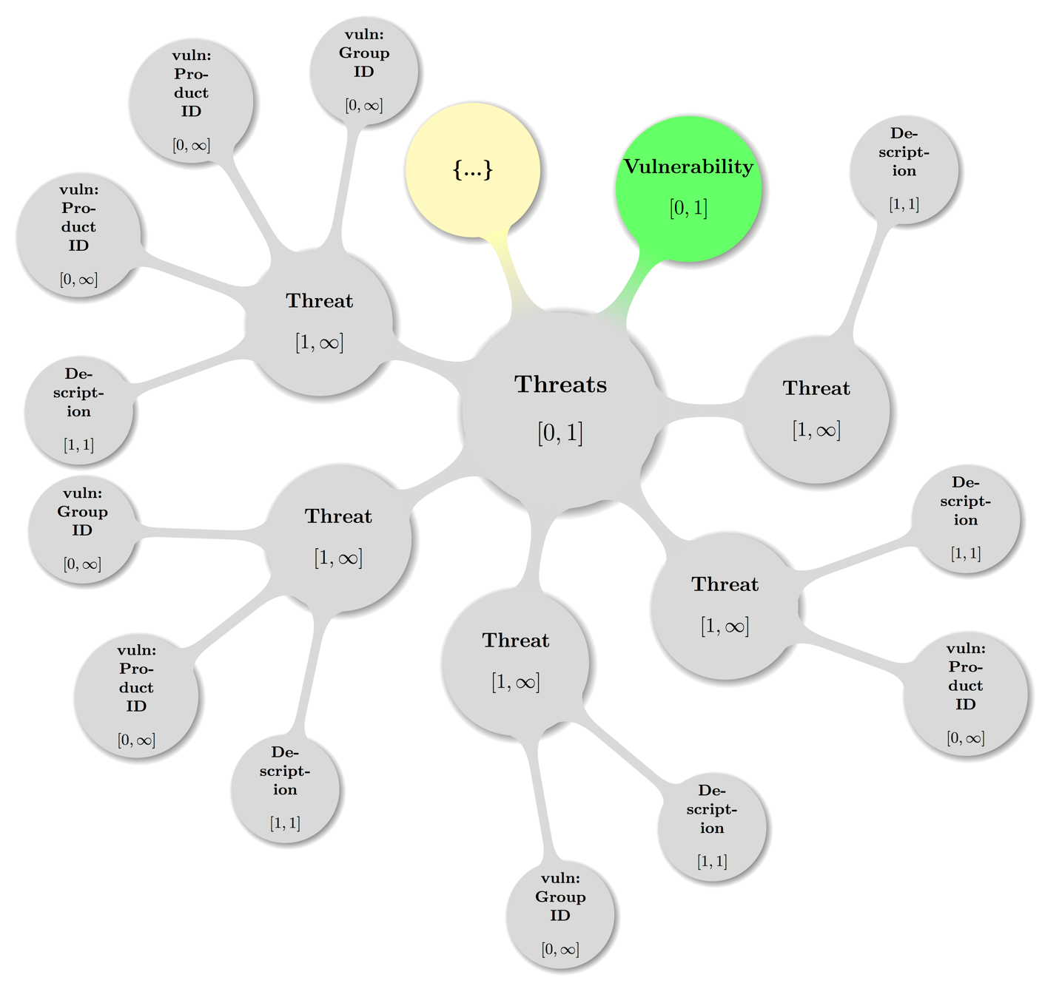

Figure 11: Visual presentation of abstract but topologically valid **Threats** instance.

6.11.1.1

### Vulnerability – Threats – Threat

vuln:Vulnerabilty / vuln:Threats / vuln:Threat

**Data Type:** container  
**Minimum Occurrences:** 1  
**Maximum Occurrences:** unbounded  
**Parent:** Threats  
**Children:** Description, Product ID, Group ID  
**Attribute:** Type, Date  
**Attribute Data Type:** enumerated list, dateTime  **Attribute Required:** yes, no

Theelementvuln:Threat contains the vulnerability kinetic information. This information can change as the vulnerability ages and new information becomes available. A given **Threats** container can contain one or more **Threat**.

A **Threat** container can be tied to one or more specific products by referencing these products using either the **Product ID** or **Group ID** child elements. If the **Threat** is meant to be general or nonspecific for all products, the **Product ID** and **Group ID** child elements should be omitted.

The *Date* attribute is optional. All dateTime values in CSAF CVRF require a date and a time, and SHOULD add time zone or offset. If neither time zone nor offset information is present, UTC SHOULD be assumed.

The *Type* of Threat is required and can be one of the following:

**Impact:** Impact contains an assessment of the impact on the user or the target set if the vulnerability is successfully exploited. (A description of the **Target Set** *Type* follows.) If applicable, for consistency and simplicity, this section can be a textual summary of the three CVSS impact metrics. These metrics measure how a vulnerability detracts from the three core security properties of an information system: Confidentiality, Integrity, and Availability.

**Exploit Status:** Exploit Status contains a description of the degree to which an exploit for the vulnerability is known. This knowledge can range from information privately held among a very small group to an issue that has been described to the public at a major conference or is being widely exploited globally. For consistency and simplicity, this section can be a mirror image of the CVSS “Exploitability” metric. However, it can also contain a more contextual status, such as “Weaponized” or “Functioning Code.”

**Target Set:** Target Set contains a description of the currently known victim population in whatever terms are appropriate. Such terms may include: operating system platform, types of products, user segments, and geographic distribution.

Example

See example in section 6.11.1.1

#### Vulnerability – Threats – Threat – Description

vuln:Vulnerabilty / vuln:Threats / vuln:Threat / vuln:Description

**Data Type:** string  
**Range:** unrestricted  
**Minimum Occurrences:** 1  
**Maximum Occurrences:** 1  
**Parent:** Threat

The elementvuln:Descriptioncontains a thorough human-readable discussion of the **Threat**.

Examples

Example 57: Impact:

<Threat Type="Impact">  
 <Description>complete compromise of the integrity of affected machines </Description>  
</Threat>

Example 58: Exploit Status:

<Threat Type="Exploit Status">  
 <Description>none</Description>  
 <Date>2011-11-26T00:00:00+00:00</Date>  
 <ProductID>CVRFPID-0000</ProductID>  
</Threat>

Example 59: Exploit Status without Product ID:

<Threat Type="Exploit Status">

<Description>proof of concept</Description>  
 </Date>2011-11-26T00:00:00+00:00</Date>

</Threat>

Example 60: Target Set:

<Threat Type="Target Set">  
 <Description>Financial Institutions</Description>  
</Threat>

Example 61: Target Set variation of content:

<Threat Type="Target Set">  
 <Description>US Government Agencies</Description>  
</Threat>

Example 62: Target Set with another variation of content:

<Threat Type="Target Set">  
 <Description>All versions of BIND</Description>  
</Threat>

#### Vulnerability – Threats – Threat – Product ID

vuln:Vulnerabilty / vuln:Threats / vuln:Threat / vuln:ProductID

**Data Type:** token  
**Minimum Occurrences:** 0  
**Maximum Occurrences:** unbounded  
**Parent:** Threat

If the **Threat** pertains to a specific product, an optional elementvuln:ProductIDcan be added to reference that product. The reference is made using the unique *Product ID* attribute of a **Full Product Name** element that is defined in the **Product Tree**. If a **Threat** applies to more than one Product, you can add multiple **Product ID** elements accordingly, or add the **Group ID** element (see below) instead.

Example

See example in section 6.11.1.1

#### Vulnerability – Threats – Threat – Group ID

vuln:Vulnerabilty / vuln:Threats / vuln:Threat / vuln:GroupID

**Data Type:** token  
**Minimum Occurrences:** 0  
**Maximum Occurrences:** unbounded  
**Parent:** Threat

If the **Threat** pertains to several products that have been logically grouped into a **Product Group** optional elementvuln:GroupIDcan be added to reference that group of products. The reference is made using the unique *Group ID* attribute of a **Group** element that is defined in the **Product Tree**. If a **Threat** applies to more than one group of products, you can add multiple **Group ID** elements accordingly.

## Vulnerability – CVSS Score Sets

vuln:Vulnerabilty / vuln:CVSSScoreSets

**Data Type:** container  
**Minimum Occurrences:** 0  
**Maximum Occurrences:** 1  
**Parent:** Vulnerability  
**Children:** Score Set V2, Score Set V3

The optional elementvuln:CVSSScoreSetsis a container that holds one or more of the **Score Set V2** (deprecated) or **Score Set V3** containers. Note: If both types are present, then **V2** instances come first.

Visual Overview

Map of some valid **CVSS Score Sets** configuration including the parent node (**Vulnerability**) — again the node with label {…} indicates further possible **Score Set V3** or ***Score Set V2*** (deprecated) subtrees:

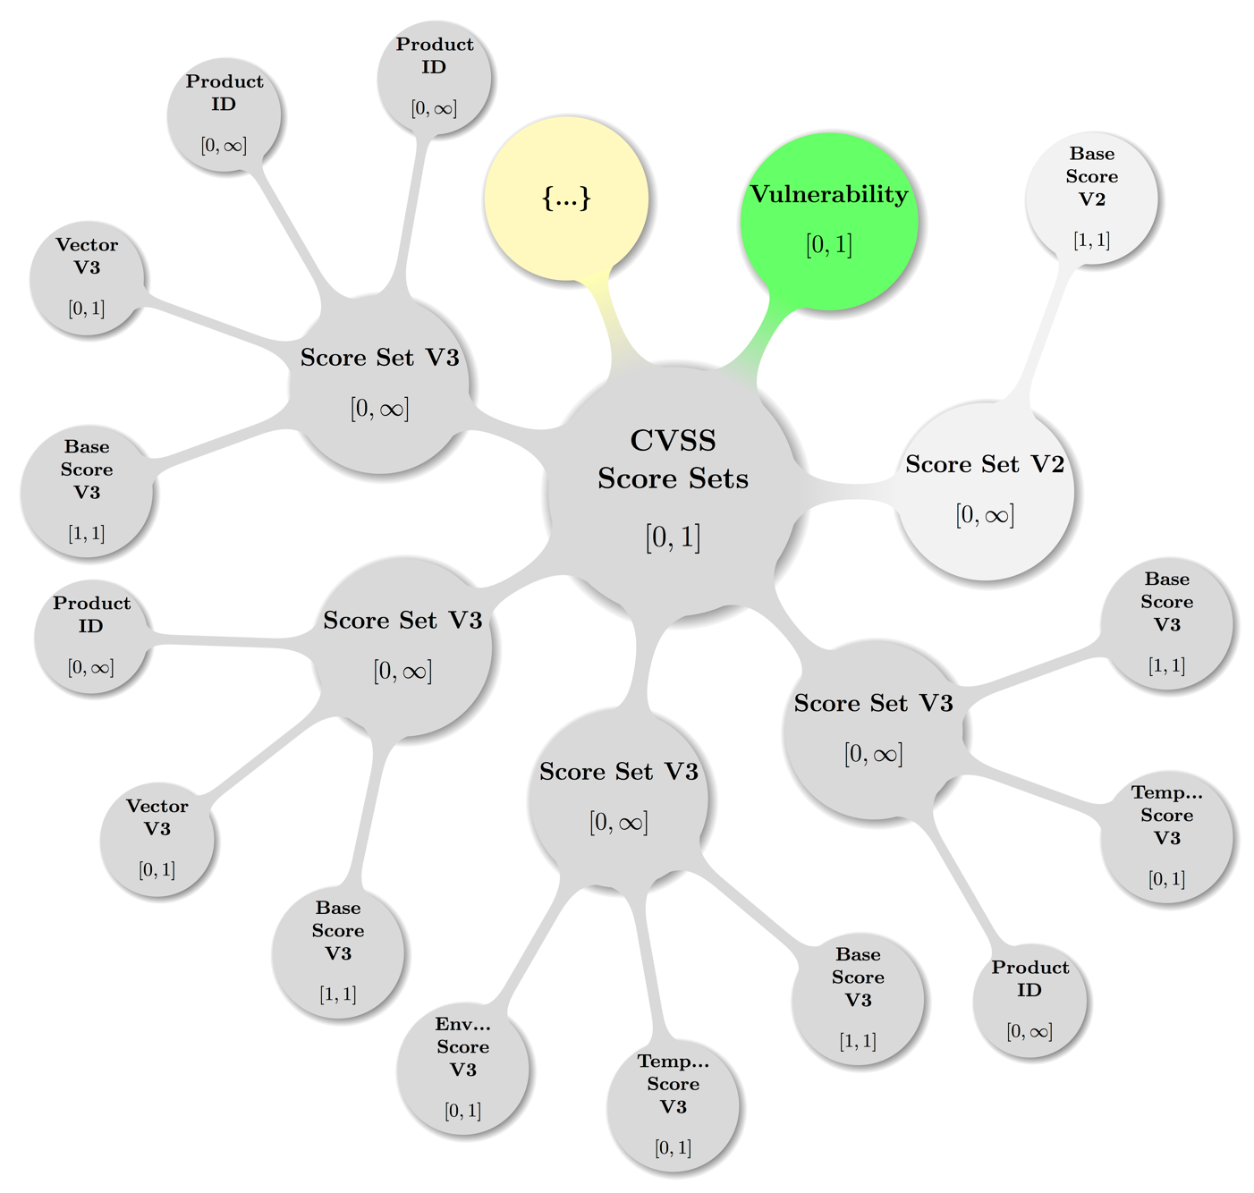

Figure 12: Visual presentation of abstract but topologically valid **CVSS Score Sets** instance.

### Vulnerability – CVSS Score Sets – Score Set V2

vuln:Vulnerabilty / vuln:CVSSScoreSets / vuln:ScoreSetV2

**Data Type:** container  
**Minimum Occurrences:** 0  
**Maximum Occurrences:** unbounded  
**Parent:** CVSS Score Sets  
**Children:** Base Score V2, Temporal Score V2, Environmental Score V2,  
 Vector V2, Product ID

The optional elementvuln:ScoreSetV2is a container that holds actual CVSS version 2 metrics [CVSS2]. The only required element of CVSS version 2 is the **Base Score**. If a value of the temporal or environmental score is set to “not defined,” either **Temporal Score** or **Environmental Score** can be omitted.

A **Score Set** container can be tied to one or more specific products by referencing these products using the **Product ID** child element. If the **Score Set** is meant to be applied for all products, the *Product ID* attribute should be omitted.

Note there is a constraint in place to prevent having a single product assigned to two different score sets within the scope of a **Vulnerability**. Likewise, a **Score Set** cannot be tied to a **Product Group** due to the fact that a single product can be a member of more than one product group. Without this constraint, it would be possible to assign conflicting base score information to one and the same product.

#### Vulnerability – CVSS Score Sets – Score Set V2 – Base Score V2

vuln:Vulnerabilty / vuln:... / vuln:ScoreSetV2 / vuln:BaseScoreV2

**Data Type:** float  
**Range:** 0.0 – 10.0  
**Minimum Occurrences:** 1  
**Maximum Occurrences:** 1  
**Parent:** Score Set V2

The optional elementvuln:BaseScoreV2contains the numeric value of the computed CVSS version 2 base score, which should be a float from 0 to 10.0.

#### Vulnerability – CVSS Score Sets – Score Set V2 – Temporal Score V2

vuln:Vulnerabilty / vuln:... / vuln:ScoreSetV2 / vuln:TemporalScoreV2

**Data Type:** float  
**Range:** 0.0 – 10.0  
**Minimum Occurrences:** 0  
**Maximum Occurrences:** 1  
**Parent:** Score Set V2

The optional elementvuln:TemporalScoreV2contains the numeric value of the computed CVSS version 2 temporal score, which should be a float from 0 to 10.0.

#### Vulnerability – CVSS Score Sets – Score Set V2 – Environmental ScoreV2

vuln:Vulnerabilty / vuln:... / vuln:ScoreSetV2 / vuln:EnvironmentalScoreV2

**Data Type:** float  
**Range:** 0.0 – 10.0  
**Minimum Occurrences:** 0  
**Maximum Occurrences:** 1  
**Parent:** Score Set V2

The optional elementvuln:EnvironmentalScoreV2contains the numeric value of the computed CVSS version 2 environmental score, which should be a float from 0 to 10.0. This metric is typically reserved for use by the end user and is specific to the environment in which the affected product is deployed.

#### Vulnerability – CVSS Score Sets – Score Set V2 – Vector V2

vuln:Vulnerabilty / vuln:... / vuln:ScoreSetV2 / vuln:VectorV2

**Data Type:** string  
**Range:** 76 characters  
**Minimum Occurrences:** 0  
**Maximum Occurrences:** 1  
**Parent:** Score Set V2

The optional elementvuln:VectorV2contains the official notation that displays all the values used to compute the CVSS version 2 base, temporal, and environmental scores. This notation will follow the guidelines set forth in the CVSS v2 documentation at [CVSS2] (cf. section 2.4 “Base, Temporal, Environmental Vectors” there). Note the 76-character limitation*.*

Example

Example 63:

<VectorV2>AV:N/AC:L/Au:N/C:P/I:P/A:C/E:P/RL:O/RC:C/CDP:H/TD:M/CR:H/IR:H/AR:H<VectorV2>

#### Vulnerability – CVSS Score Sets – Score Set V2 – Product ID

vuln:Vulnerabilty / vuln:... / vuln:ScoreSetV2 / vuln:ProductID

**Data Type:** token  
**Minimum Occurrences:** 0  
**Maximum Occurrences:** unbounded  
**Parent:** Score Set V2

If the **Score Set** pertains to a specific product, a vuln:ProductIDelement can be added to reference that product. The reference is made using the unique *Product ID* attribute of a **Full Product Name** element that is defined in the **Product Tree**. If a **Score Set** applies to more than one product, you can add multiple **Product ID** elements accordingly.

Note that a single **Product ID** may not be assigned to more than one **Score Set** within the same **Vulnerability**.

### Vulnerability – CVSS Score Sets – Score Set V3

vuln:Vulnerabilty / vuln:CVSSScoreSets / vuln:ScoreSetV3

**Data Type:** container  
**Minimum Occurrences:** 0  
**Maximum Occurrences:** unbounded  
**Parent:** CVSS Score Sets  
**Children:** Base Score, Temporal Score, Environmental Score, Vector,   
 Product ID

The optional elementvuln:ScoreSetV3is a container that holds actual CVSS version 3 metrics [CVSS3]. The only required element of CVSS version 3 is the **Base Score**. If a value of the temporal or environmental score is set to “not defined,” either **Temporal Score** or **Environmental Score** can be omitted.

A **Score Set** container can be tied to one or more specific products by referencing these products using the **Product ID** child element. If the **Score Set** is meant to be applied for all products, the *Product ID* attribute should be omitted.

Note there is a constraint in place to prevent having a single product assigned to two different score sets within the scope of a **Vulnerability**. Likewise, a **Score Set** cannot be tied to a **Product Group** due to the fact that a single product can be a member of more than one product group. Without this constraint, it would be possible to assign conflicting base score information to one and the same product.

#### Vulnerability – CVSS Score Sets – Score Set V3 – Base Score V3

vuln:Vulnerabilty / vuln:... / vuln:ScoreSetV3 / vuln:BaseScoreV3

**Data Type:** float  
**Range:** 0.0 – 10.0  
**Minimum Occurrences:** 1  
**Maximum Occurrences:** 1  
**Parent:** Score Set V3

The optional elementvuln:BaseScoreV3contains the numeric value of the computed CVSS version 3 base score, which should be a float from 0 to 10.0.

#### Vulnerability – CVSS Score Sets – Score Set V3 – Temporal Score V3

vuln:Vulnerabilty / vuln:... / vuln:ScoreSetV3 / vuln:TemporalScoreV3

**Data Type:** float  
**Range:** 0.0 – 10.0  
**Minimum Occurrences:** 0  
**Maximum Occurrences:** 1  
**Parent:** Score Set V3

The optional elementvuln:TemporalScoreV3contains the numeric value of the computed CVSS version 3 temporal score, which should be a float from 0 to 10.0.

#### Vulnerability – CVSS Score Sets – Score Set V3 – Environmental ScoreV3

vuln:Vulnerabilty / vuln:... / vuln:ScoreSetV3 / vuln:EnvironmentalScoreV3

**Data Type:** float  
**Range:** 0.0 – 10.0  
**Minimum Occurrences:** 0  
**Maximum Occurrences:** 1  
**Parent:** Score Set V3

The optional elementvuln:EnvironmentalScoreV3contains the numeric value of the computed CVSS version 3 environmental score, which should be a float from 0 to 10.0. This metric is typically reserved for use by the end user and is specific to the environment in which the affected product is deployed.

#### Vulnerability – CVSS Score Sets – Score Set V3 – Vector V3

vuln:Vulnerabilty / vuln:... / vuln:ScoreSetV3 / vuln:VectorV3

**Data Type:** string  
**Range:** 76 characters  
**Minimum Occurrences:** 0  
**Maximum Occurrences:** 1  
**Parent:** Score Set V3

The optional elementvuln:VectorV3contains the official notation that displays all the values used to compute the CVSS version 3 base, temporal, and environmental scores. This notation will follow the guidelines set forth in the CVSS v3 documentation at [CVSS3] (cf. section “Vector String” pp.17,18 there). Note the 76-character limitation*.*

Example

Example 64:

<VectorV3>CVSS:3.0/AV:N/AC:L/PR:H/UI:N/S:U/C:L/I:L/A:N<VectorV3>

Example 65:

<VectorV3>CVSS:3.0/S:U/AV:N/AC:L/PR:H/UI:N/C:L/I:L/A:N/E:F/RL:X<VectorV3>

#### Vulnerability – CVSS Score Sets – Score Set V3 – Product ID

vuln:Vulnerabilty / vuln:... / vuln:ScoreSetV3 / vuln:ProductID

**Data Type:** token  
**Minimum Occurrences:** 0  
**Maximum Occurrences:** unbounded  
**Parent:** Score Set V3

If the **Score Set** pertains to a specific product, a vuln:ProductIDelement can be added to reference that product. The reference is made using the unique *Product ID* attribute of a **Full Product Name** element that is defined in the **Product Tree**. If a **Score Set** applies to more than one product, you can add multiple **Product ID** elements accordingly.

Note that a single **Product ID** may not be assigned to more than one **Score Set** within the same **Vulnerability**.

## Vulnerability – Remediations

vuln:Vulnerabilty / vuln:Remediations

**Data Type:** container  
**Minimum Occurrences:** 0  
**Maximum Occurrences:** 1  
**Parent:** Vulnerability  
**Children:** Remediation

The optional elementvuln:Remediationsis a container that holds one or more **Remediation** containers, which will have details on how to remediate a vulnerability.

Visual Overview

Map of some valid **Remediations** configuration including the parent node (**Vulnerability**) — again with the node labeled {…} indicating further possible **Remediation** subtrees:

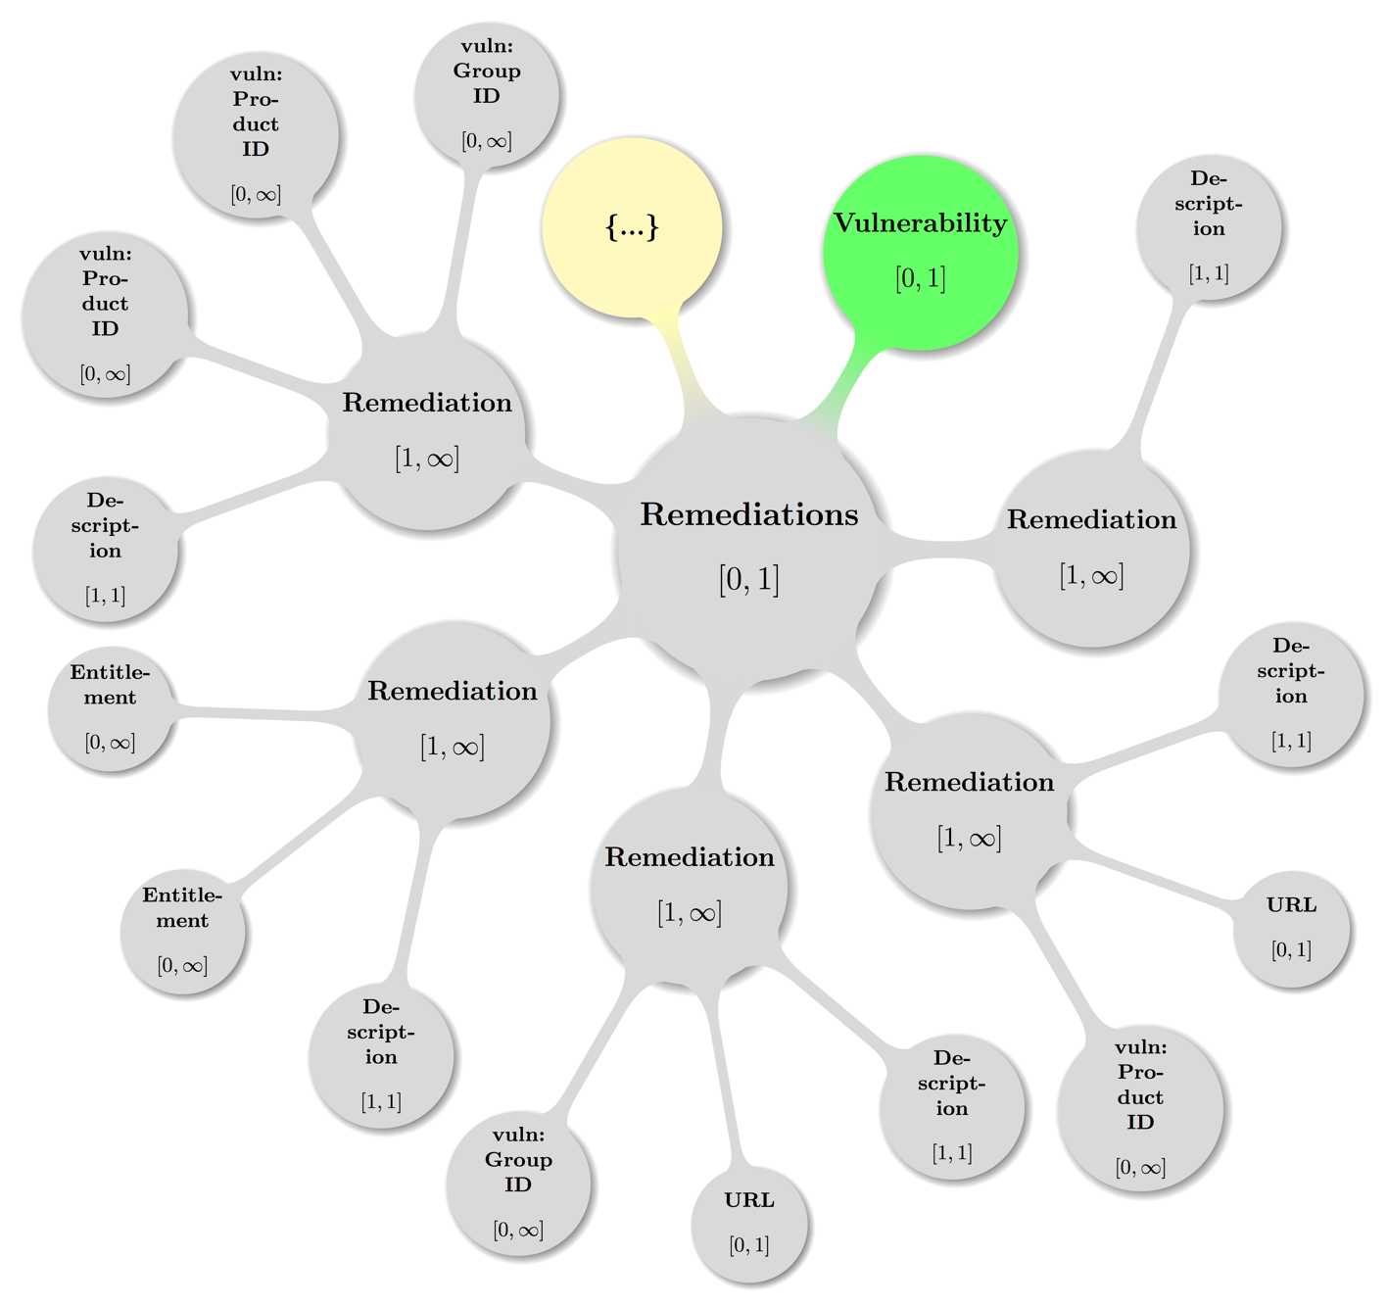

Figure 13: Visual presentation of abstract but topologically valid **Remediations** instance.

### Vulnerability – Remediations – Remediation

vuln:Vulnerabilty / vuln:Remediations / vuln:Remediation

**Data Type:** container  
**Minimum Occurrences:** 1  
**Maximum Occurrences:** unbounded  
**Parent:** Remediations  
**Children:** Description, Entitlement, URL, Product ID, Group ID  
**Attribute:** Type   
**Attribute Data Type:** enumerated list  
**Attribute Range:** {Workaround, Mitigation, Vendor Fix, None Available, Will Not Fix} **Attribute Required:** yes

The optional elementvuln:Remediationis a container that holds specific details on how to handle (and presumably, fix) a vulnerability. A given **Remediations** container can contain one or more **Remediation** containers.

A **Remediation** container can be tied to one or more specific products by referencing these products using either the **Product ID** or **Group ID** child elements. If the **Remediation** is meant to be general or nonspecific for all products, the **Product ID** and **Group ID** child elements should be omitted.

The *Type* attribute is required and can be one of the following:

* **Workaround:** Workaround contains information about a configuration or specific deployment scenario that can be used to avoid exposure to the vulnerability. There may be none, one, or more workarounds available. This is typically the “first line of defense” against a new vulnerability before a mitigation or vendor fix has been issued or even discovered.
* **Mitigation:** Mitigation contains information about a configuration or deployment scenario that helps to reduce the risk of the vulnerability but that does not resolve the vulnerability on the affected product. Mitigations may include using devices or access controls external to the affected product. Mitigations may or may not be issued by the original author of the affected product, and they may or may not be officially sanctioned by the document producer.
* **Vendor Fix:** Vendor Fix contains information about an official fix that is issued by the original author of the affected product. Unless otherwise noted, it is assumed that this fix fully resolves the vulnerability.
* **None Available:** Currently there is no fix available. Description should contain details about why there is no fix.
* **Will Not Fix:** There is no fix for the vulnerability and there never will be one. This is often the case when a product has been orphaned, end-of-lifed, or otherwise deprecated. Description should contain details about why there will be no fix issued.

Optionally, **Remediation** can contain information and constraints about how to obtain fixes via the **Entitlement** element.

#### Vulnerability – Remediations – Remediation – Description

vuln:Vulnerabilty / vuln:... / vuln:Remediation / vuln:Description

**Data Type:** string  
**Range:** unrestricted  
**Minimum Occurrences:** 1  
**Maximum Occurrences:** 1  
**Parent:** Remediation

The elementvuln:Descriptionwill contain a thorough human-readable discussion of the Remediation.

#### Vulnerability – Remediations – Remediation – Entitlement

vuln:Vulnerabilty / vuln:... / vuln:Remediation / vuln:Entitlement

**Data Type:** string  
**Range:** unrestricted  
**Minimum Occurrences:** 0  
**Maximum Occurrences:** 1  
**Parent:** Remediation

The elementvuln:Entitlementcontains any possible vendor-defined constraints for obtaining fixed software or hardware that fully resolves the vulnerability. This element will often contain information about service contracts or service-level agreements that is directed toward customers of large vendors.

Example

Example 66:

<Entitlement>

Cisco customers with service contracts that entitle them to regular software updates   
 should obtain security fixes through their usual update channels, generally from the   
 Cisco website. Cisco recommends contacting the TAC only with specific and imminent   
 problems or questions.\r\nAs a special customer service, and to improve the overall   
 security of the Internet, Cisco may offer customers free of charge software updates to   
 address security problems. If Cisco has offered a free software update to address a   
 specific issue, noncontract customers who are eligible for the update may obtain it by   
 contacting the Cisco TAC using any of the means described in the Contact Summary   
 section of this document. To verify their entitlement, individuals who contact the TAC   
 should have available the URL of the Cisco document that is offering the   
 upgrade.\r\nAll aspects of this process are subject to change without notice and on a   
 case-by-case basis. No particular level of response is guaranteed for any specific   
 issue or class of issues.

</Entitlement>

#### Vulnerability – Remediations – Remediation – URL

vuln:Vulnerabilty / vuln:... / vuln:Remediation / vuln:URL

**Data Type:** aniURI  
**Range:** unrestricted  
**Minimum Occurrences:** 0  
**Maximum Occurrences:** 1  
**Parent:** Remediation

The optional elementvuln:URLcontains the URL to the Remediation.

Example

See example in section 6.13.1.4

#### Vulnerability – Remediations – Remediation – Product ID

vuln:Vulnerabilty / vuln:... / vuln:Remediation / vuln:ProductID

**Data Type:** token  
**Minimum Occurrences:** 0  
**Maximum Occurrences:** unbounded  
**Parent:** Remediation

If the **Remediation** pertains to a specific product, a vuln:ProductIDcan be added to reference that product. The reference is made using the unique *Product ID* attribute of a **Full Product Name** element that is defined in the **Product Tree**. If a **Remediation** applies to more than one Product, you can add multiple **Product ID** elements accordingly, or add the **Group ID** element (see below) instead.

Example

Example 67:

<Remediation Type="Vendor Fix">

<Description>

this is an official fix for Test Product and here are the details...  
 </Description>

<URL>http://foo.foo/bar/</URL>

<Product ID>CVRFPID-0000</Product ID>

</Remediation>

#### Vulnerability – Remediations – Remediation – Group ID

vuln:Vulnerabilty / vuln:... / vuln:Remediation / vuln:GroupID

**Data Type:** token  
**Minimum Occurrences:** 0  
**Maximum Occurrences:** unbounded  
**Parent:** Remediation

If the **Remediation** pertains to several products that have been logically grouped into a **Product Group**, a vuln:GroupID element can be added to reference that group of products. The reference is made using the unique *Group ID* attribute of a **Group** element that is defined in the **Product Tree**. If a **Remediation** applies to more than one group of products, you can add multiple **Group ID** elements accordingly.

## Vulnerability – References

vuln:Vulnerability / vuln:References

**Data Type:** container  
**Minimum Occurrences:** 0  
**Maximum Occurrences:** unbounded  
**Parent:** Vulnerability  
**Children:** Reference

Theoptionalelementvuln:Referencesis a container that should include citations to any conferences, papers, advisories, and other resources that are specific to the vulnerability section and considered to be of value to the document consumer. For every **References** container, there must be at least one **Reference** element and each **Reference** element must contain one **URL** and one **Description.**

Example

See example in section 6.14.1.2

Visual Overview

Map of some valid **References** configuration including the parent node (**Vulnerability**) — again with the node labeled {…} indicating further possible **Reference** subtrees:

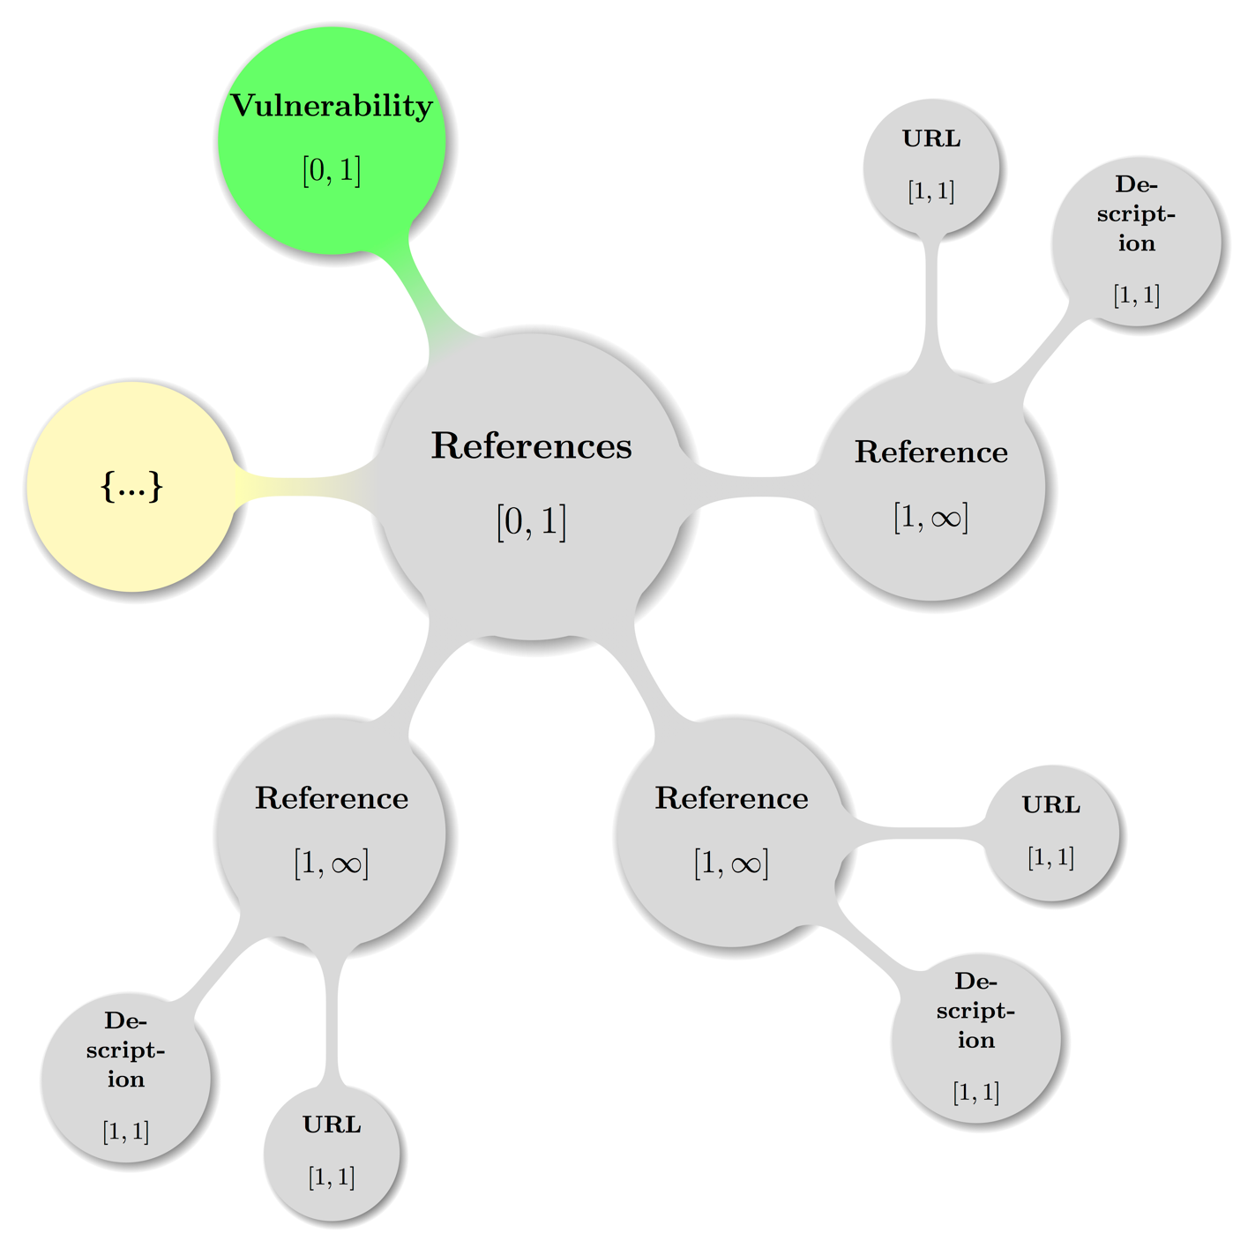

Figure 14: Visual presentation of abstract but topologically valid **References** instance.

### Vulnerability – References – Reference

vuln:Vulnerability / vuln:References / vuln:Reference

**Data Type:** container  
**Minimum Occurrences:** 1  
**Maximum Occurrences:** unbounded  
**Parent:** References  
**Children:** URL, Description  
**Attribute:** Type  
**Attribute Data Type:** enumerated list  
**Attribute Required:** yes  
**Attribute Default Value:** External

Theelementvuln:Referencecontains a description of a related document specific to a vulnerability section of a CVRF document. This may include a plaintext or HTML version of the advisory or other related documentation, such as white papers or mitigation documentation.

The *Type* attribute denotes the type of the document reference relative to the CVRF document itself. The following types are available:

* **External**: The default value indicates the reference is external to the CVRF document.
* **Self**: This indicates the related document is actually a direct reference to itself

Example

See example in section 6.14.1.2

#### Vulnerability – References – Reference – URL

vuln:Vulnerability / vuln:References / vuln:Reference / vuln:URL

**Data Type:** anyURI  
**Range:** unrestricted  
**Minimum Occurrences:** 1  
**Maximum Occurrences:** 1  
**Parent:** Reference

Theelementvuln:URLcontains the fixed URL or location of the reference.

Example

See example in section 6.14.1.2

#### Vulnerability – References – Reference – Description

vuln:Vulnerability / vuln:References / vuln:Reference / vuln:Description

**Data Type:** string  
**Range:** unrestricted  
**Minimum Occurrences:** 1  
**Maximum Occurrences:** 1  
**Parent:** Reference

Theelementvuln:Descriptionholds a descriptive title or name of the reference.

Example

Example 68:

<References>  
 <Reference Type="External">

<URL>http://foo.foo/bar/</URL>

<Description xml:lang="fr">C'est un test de référence</Description>  
 </Reference>  
</References>

## Vulnerability – Acknowledgements

vuln:Vulnerability / vuln:Acknowledgements

**Data Type:** container  
**Minimum Occurrences:** 0  
**Maximum Occurrences:** 1  
**Parent:** Vulnerability  
**Children:** Acknowledgement

Theoptionalelementvuln:Acknowledgementsis a container that holds one or more **Acknowledgment** containers, which contain recognition of external parties. This **Acknowledgments** container is different from the one at the document level because it is specifically related to the vulnerability in question**.**

Visual Overview

Map of some valid **Acknowledgements** configuration including the parent node (**Vulnerability**) — again with the node labeled {…} indicating further possible **Acknowledgement** subtrees:

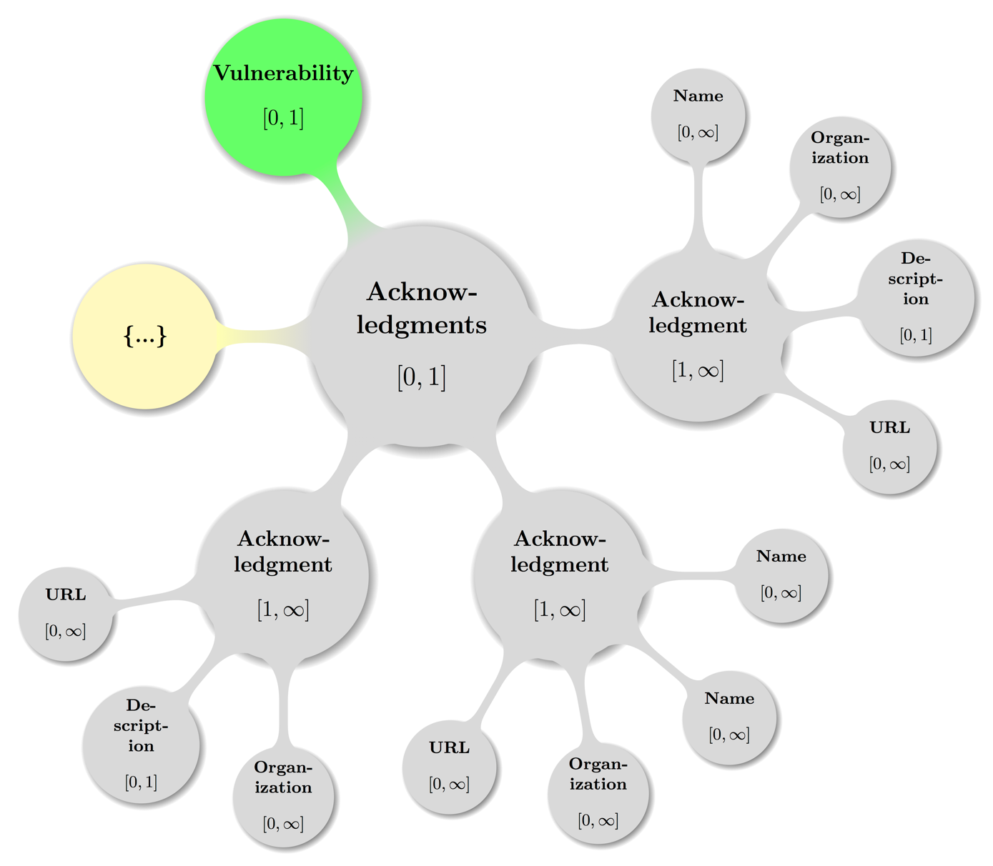

Figure 15: Visual presentation of abstract but topologically valid **Acknowledgements** instance.

### Vulnerability – Acknowledgements – Acknowledgement

vuln:Vulnerability / vuln:Acknowledgements / vuln:Acknowledgement

**Data Type:** container  
**Minimum Occurrences:** 1  
**Maximum Occurrences:** unbounded  
**Parent:** Acknowledgements  
**Children:** Name, Organization, Description, URL

Theelementvuln:Acknowledgementcontains recognition of external parties who were instrumental in the discovery of, reporting of, and response to the vulnerability. This element indicates collaboration with the security community in a positive fashion and is an important part of a notice or advisory. Care should be taken to ensure that individuals would like to be acknowledged before they are included.

External parties who have worked with the document producer may be recognized for their work. This should be applied liberally; if someone reports an issue and then discloses it publicly, that party might still be credited.

If the original discoverer is not concerned with recognition, or the issue was discovered internally by the document producer, this field can be omitted.

An acknowledgment container may contain three different types of child elements: **Name**, **Organization**, and/or a **Description**. All are described below.

Example

See example in section 6.15.1.4

#### Vulnerability – Acknowledgements – Acknowledgement – Name

vuln:Vulnerability / vuln:... / vuln:Acknowledgement / vuln:Name

**Data Type:** string  
**Range:** unrestricted  
**Minimum Occurrences:** 1  
**Maximum Occurrences:** unbounded  
**Parent:** Acknowledgement

Theelementvuln:Namecontains the name of the party being acknowledged.

Example

See example in section 6.15.1.4

#### Vulnerability – Acknowledgements – Acknowledgement – Organization

vuln:Vulnerability / vuln:... / vuln:Acknowledgement / vuln:Organization

**Data Type:** string  
**Range:** unrestricted  
**Minimum Occurrences:** 1  
**Maximum Occurrences:** unbounded  
**Parent:** Acknowledgement

Theelementvuln:Organizationcontains the organization of the party or, if the Name is omitted, the organization itself that is being acknowledged.

Example

See example in section 6.15.1.4

#### Vulnerability – Acknowledgements – Acknowledgement – Description

vuln:Vulnerability / vuln:... / vuln:Acknowledgement / vuln:Description

**Data Type:** string  
**Range:** unrestricted  
**Minimum Occurrences:** 0  
**Maximum Occurrences:** 1  
**Parent:** Acknowledgement

Theelementvuln:Descriptioncan contain any contextual details the document producers wish to make known about the acknowledgment or acknowledged parties.

If attributing to multiple organizations, each contributor should be grouped with that **Organization** within a single **Acknowledgment** container. An **Organization**-specific acknowledgment may be added within each **Acknowledgment** container by the **Description** element. If an overall general or aggregate acknowledgment is to be added, an **Acknowledgment** container that contains a single **Description** element may be used.

Example

See example in section 6.15.1.4

#### Vulnerability – Acknowledgements – Acknowledgement – URL

vuln:Vulnerability / vuln:... / vuln:Acknowledgement / vuln:URL

**Data Type:** anyURI  
**Range:** unrestricted  
**Minimum Occurrences:** 0  
**Maximum Occurrences:** unbounded  
**Parent:** Acknowledgement

Theelementvuln:URLcontains the URL or location of the reference to be acknowledged.

Example

Example 69:

<Acknowledgments>  
 <Acknowledgment>  
 <Name>[Name 1]</Name>  
 <Name>[Name 2]</Name>  
 <Organization>[OrgName]</Organization>  
 <URL>http://foo.foo/bar/</URL>  
 </Acknowledgment>  
 <Acknowledgment>

<Name>[Name 3]</Name>  
 <Organization>[OrgName]</Organization>

<Description>

Vendor X would like to thank [Name 3] from [OrgName] for reporting this issue.  
 </Description>  
 <URL>http://foo.foo/bar/</URL>  
 </Acknowledgment>  
 <Acknowledgment>

<Description>  
 Vendor X would like to thank the following researchers for their contributions to   
 making this project more secure: [Name 1], [Name 2], [Name 3]

</Description>  
 <URL>http://foo.foo/bar/</URL>

</Acknowledgment>  
</Acknowledgments>

# Conformance

## Conformance as a CVRF version 1.2 document

A document instance conforms to this specification as a CVRF version 1.2 document if it meets all of the following three conditions:

1. Is well-formed XML.
2. Consists of a single cvrf:cvrfdoc element instance as defined in   
   the namespace http://docs.oasis-open.org/csaf/ns/csaf-cvrf/v1.2/cvrf.
3. Is valid XML.

[CSAF-7.1-1]

1. Acknowledgments

The following individuals were members of the OASIS CSAF Technical Committee during the creation of this specification and their contributions are gratefully acknowledged:

Adam Montville, CIS Sarah Kelley, CIS

Allan Thomson, LookingGlass Sean Barnum, Mitre Corporation

Anthony Berglas, Cryptsoft Pty Ltd. Stefan Hagen, Individual

Art Manion, Carnegie Mellon University Ted Bedwell, Cisco Systems

Aukjan van Belkum, EclecticIQ Thomas Schreck, Siemens AG

Bernd Grobauer, Siemens AG Tim Hudson, Cryptsoft Pty Ltd.

Beth Pumo, Kaiser Permanente Tony Cox, Cryptsoft Pty Ltd.

Bret Jordan, Symantec Corp. Trey Darley, "Kingfisher Operations, sprl"

Bruce Rich, Cryptsoft Pty Ltd. Troy Fridley, Cisco Systems

Chet Ensign, OASIS Vincent Danen, Red Hat

Chok Poh, Oracle Zach Turk, Microsoft

Chris Rouland, Individual

David Waltermire, NIST

Denny Page, TIBCO Software Inc.

Doron Shiloach, IBM

Duncan Sparrell, sFractal Consulting LLC

Eric Johnson, TIBCO Software Inc.

Feng Cao, Oracle

Greg Reaume, TELUS

Greg Scott, Cryptsoft Pty Ltd.

Harold Booth, NIST

Jamison Day, LookingGlass

Jared Semrau, "FireEye, Inc."

Jason Keirstead, IBM

Jason Masters, TELUS

Jerome Athias, Individual

Jessica Fitzgerald-McKay, National Security Agency

Jonathan Bitle, Kaiser Permanente

Justin Corlett, Cryptsoft Pty Ltd.

Karen Scarfone, Individual

Kazuo Noguchi, "Hitachi, Ltd."

Kent Landfield, Intel Corporation

Lothar Braun, Siemens AG

Louis Ronnau, Cisco Systems

Mark Davidson, NC4

Mark-David McLaughlin, Cisco Systems

Masato Terada, "Hitachi, Ltd."

Nicole Gong, Mitre Corporation

Omar Santos, Cisco Systems

Patrick Maroney, Wapack Labs LLC

Paul Patrick, "FireEye, Inc."

Peter Allor, IBM

Phillip Boles, "FireEye, Inc."

Ravi Balupari, Netskope

Rich Reybok, ServiceNow

Richard Struse, DHS Office of Cybersecurity and Communications (CS&C)

Ritwik Ghoshal, Oracle

Robert Coderre, VeriSign

Robin Cover, OASIS

Rupert Wimmer, Siemens AG

Sanjiv Kalkar, Individual

1. Examples

Some real-world examples of CVRF version 1.2 advisories in XML format are given in this appendix and in the hope, they are useful (major edits on text content to emphasize structure).

* 1. Sample Security Advisory A

Security advisory from the year 2017:

<?xml version="1.0" encoding="UTF-8"?>  
<cvrf:cvrfdoc   
  xmlns:cpe="http://cpe.mitre.org/language/2.0"  
  xmlns:cvrf="http://docs.oasis-open.org/csaf/ns/csaf-cvrf/v1.2/cvrf"  
  xmlns:cvrf-common="http://docs.oasis-open.org/csaf/ns/csaf-cvrf/v1.2/common"  
  xmlns:cvssv2="http://scap.nist.gov/schema/cvss-v2/1.0"  
  xmlns:cvssv3="https://www.first.org/cvss/cvss-v3.0.xsd"  
  xmlns:dc="http://purl.org/dc/elements/1.2/"  
  xmlns:ns0="http://purl.org/dc/elements/1.1/"  
  xmlns:prod="http://docs.oasis-open.org/csaf/ns/csaf-cvrf/v1.2/prod"  
  xmlns:scap-core="http://scap.nist.gov/schema/scap-core/1.0"  
  xmlns:sch="http://purl.oclc.org/dsdl/schematron"  
  xmlns:vuln="http://docs.oasis-open.org/csaf/ns/csaf-cvrf/v1.2/vuln"  
  xmlns:xsi="http://www.w3.org/2001/XMLSchema-instance"  
  >  
  <!-- Document wide context info -->  
 <cvrf:DocumentTitle>AppY Stream Control Transmission Protocol</cvrf:DocumentTitle>

<cvrf:DocumentType>Security Advisory</cvrf:DocumentType>

<cvrf:DocumentPublisher Type="Vendor">

<cvrf:ContactDetails>Emergency Support: ...</cvrf:ContactDetails>

<cvrf:IssuingAuthority>... Team (PSIRT)....</cvrf:IssuingAuthority>

</cvrf:DocumentPublisher>

<cvrf:DocumentTracking>

<cvrf:Identification>

<cvrf:ID>vendorix-sa-20170301-abc</cvrf:ID>

</cvrf:Identification>

<cvrf:Status>Final</cvrf:Status>

<cvrf:Version>1.0</cvrf:Version>

<cvrf:RevisionHistory>

<cvrf:Revision>

<cvrf:Number>1.0</cvrf:Number>

<cvrf:Date>2017-03-01T14:58:48</cvrf:Date>

<cvrf:Description>Initial public release.</cvrf:Description>

</cvrf:Revision>

</cvrf:RevisionHistory>

<cvrf:InitialReleaseDate>2017-03-01T16:00:00</cvrf:InitialReleaseDate>

<cvrf:CurrentReleaseDate>2017-03-01T14:58:48</cvrf:CurrentReleaseDate>

<cvrf:Generator>

<cvrf:Engine>TVCE</cvrf:Engine>

</cvrf:Generator>

</cvrf:DocumentTracking>

<cvrf:DocumentNotes>

<cvrf:Note Title="Summary" Type="General" Ordinal="1">A vulnerability...</cvrf:Note>

<cvrf:Note Title="CVSS 3.0 Notice" Type="Other" Ordinal="2">... </cvrf:Note>

</cvrf:DocumentNotes>

<cvrf:DocumentReferences>

<cvrf:Reference Type="Self">

<cvrf:URL>https://example.com/sec/vendorix-sa-20170301-abc</cvrf:URL>

<cvrf:Description>Vendorix Foo AppY...</cvrf:Description>

</cvrf:Reference>

</cvrf:DocumentReferences>

  <!-- Product tree section -->  
 <prod:ProductTree>

<prod:Branch Name="Vendorix" Type="Vendor">

<prod:Branch Name="... Appliances" Type="Product Name">

<prod:Branch Name="1.0" Type="Product Version">

<prod:Branch Name=".0" Type="Service Pack">

<prod:FullProductName ProductID="CVRFPID-223152">...

AppY 1.0.0</prod:FullProductName>

</prod:Branch>

<prod:Branch Name="(2)" Type="Service Pack">

<prod:FullProductName ProductID="CVRFPID-223153">...

AppY 1.0(2)</prod:FullProductName>

</prod:Branch>

</prod:Branch>

<prod:Branch Name="1.1" Type="Product Version">

<prod:Branch Name=".0" Type="Service Pack">

<prod:FullProductName ProductID="CVRFPID-223155">...

AppY 1.1.0</prod:FullProductName>

</prod:Branch>

<prod:Branch Name="(1)" Type="Service Pack">

<prod:FullProductName ProductID="CVRFPID-223156">...

AppY 1.1(1)</prod:FullProductName>

</prod:Branch>

</prod:Branch>

</prod:Branch>

</prod:Branch>

</prod:ProductTree>

  <!-- Vulnerability section -->  
 <vuln:Vulnerability Ordinal="1">

<vuln:Title>... Transmission Protocol ...</vuln:Title>

<vuln:ID SystemName="Vendorix Bug ID">VDXvc83320</vuln:ID>

<vuln:Notes>

<vuln:Note Title="Summary" Type="Summary" Ordinal="1">A vuln ...</vuln:Note>

<vuln:Note Title="Vendorix Bug IDs" Type="Other" Ordinal="3">

VDXvc83320</vuln:Note>

</vuln:Notes>

<vuln:CVE>CVE-2017-3826</vuln:CVE>

<vuln:ProductStatuses>

<vuln:Status Type="Known Affected">

<vuln:ProductID>CVRFPID-223152</vuln:ProductID>

<vuln:ProductID>CVRFPID-223153</vuln:ProductID>

<vuln:ProductID>CVRFPID-223155</vuln:ProductID>

<vuln:ProductID>CVRFPID-223156</vuln:ProductID>

</vuln:Status>

</vuln:ProductStatuses>

<vuln:CVSSScoreSets>

<vuln:ScoreSetV3>

<vuln:BaseScoreV3>7.5</vuln:BaseScoreV3>

<vuln:VectorV3>CVSS:3.0/AV:N/AC:L/PR:N/UI:N/S:U/C:N/I:N/A:H</vuln:VectorV3>

</vuln:ScoreSetV3>

</vuln:CVSSScoreSets>

<vuln:Remediations>

<vuln:Remediation Type="Workaround">

<vuln:Description>There are no workarounds that ...</vuln:Description>

</vuln:Remediation>

</vuln:Remediations>

<vuln:References>

<vuln:Reference Type="Self">

<vuln:URL>https://example.com/sec/vendorix-sa-20170301-abc</vuln:URL>

<vuln:Description>... AppY Stream ...</vuln:Description>

</vuln:Reference>

</vuln:References>

</vuln:Vulnerability>

  <!-- No more elements to follow -->  
</cvrf:cvrfdoc>

* 1. Sample Security Advisory B

Another security advisory from the year 2017 as issued by Red Hat and migrated to CSAF CVRF 1.2 from the source CVRF 1.1 by simply updating the namespaces and prefixing all elements with the corresponding namespace of either cvrf, prod, or vuln. Additionally, 4 comments were added, to visually separate the three semantic top level elements **Document** Context, **Product Tree**, and **Vulnerability**): SPECIAL_QUEST_TO_TC_MEMBERS_FROM_RED_HAT_IF_MOD_COPY_OK_?

<?xml version="1.0" encoding="utf-8"?>

<cvrf:cvrfdoc xmlns:cpe="http://cpe.mitre.org/language/2.0"

xmlns:cvrf="http://docs.oasis-open.org/csaf/ns/csaf-cvrf/v1.2/cvrf"

xmlns:cvrf-common="http://docs.oasis-open.org/csaf/ns/csaf-cvrf/v1.2/common"

xmlns:cvssv2="http://scap.nist.gov/schema/cvss-v2/1.0"

xmlns:cvssv3="https://www.first.org/cvss/cvss-v3.0.xsd"

xmlns:dc="http://purl.org/dc/elements/1.1/"

xmlns:prod="http://docs.oasis-open.org/csaf/ns/csaf-cvrf/v1.2/prod"

xmlns:scap-core="http://scap.nist.gov/schema/scap-core/1.0"

xmlns:sch="http://purl.oclc.org/dsdl/schematron"

xmlns:vuln="http://docs.oasis-open.org/csaf/ns/csaf-cvrf/v1.2/vuln"

xmlns:xsi="http://www.w3.org/2001/XMLSchema-instance"

>

<!-- Document wide context info -->

<cvrf:DocumentTitle xml:lang="en">Red Hat Security Advisory: python-oslo-middleware security update</cvrf:DocumentTitle>

<cvrf:DocumentType>Security Advisory</cvrf:DocumentType>

<cvrf:DocumentPublisher Type="Vendor">

<cvrf:ContactDetails>secalert@redhat.com</cvrf:ContactDetails>

<cvrf:IssuingAuthority>Red Hat Product Security</cvrf:IssuingAuthority>

</cvrf:DocumentPublisher>

<cvrf:DocumentTracking>

<cvrf:Identification>

<cvrf:ID>RHSA-2017:0435</cvrf:ID>

</cvrf:Identification>

<cvrf:Status>Final</cvrf:Status>

<cvrf:Version>1</cvrf:Version>

<cvrf:RevisionHistory>

<cvrf:Revision>

<cvrf:Number>1</cvrf:Number>

<cvrf:Date>2017-03-02T21:13:00Z</cvrf:Date>

<cvrf:Description>Current version</cvrf:Description>

</cvrf:Revision>

</cvrf:RevisionHistory>

<cvrf:InitialReleaseDate>2017-03-02T21:13:00Z</cvrf:InitialReleaseDate>

<cvrf:CurrentReleaseDate>2017-03-02T21:13:00Z</cvrf:CurrentReleaseDate>

<cvrf:Generator>

<cvrf:Engine>Red Hat rhsa-to-cvrf 2.0</cvrf:Engine>

<cvrf:Date>2017-03-04T05:06:05Z</cvrf:Date>

</cvrf:Generator>

</cvrf:DocumentTracking>

<cvrf:DocumentNotes>

<cvrf:Note Title="Topic" Type="Summary" Ordinal="1" xml:lang="en">

An update for python-oslo-middleware is now available for Red Hat OpenStack Platform 9.0 (Mitaka).

Red Hat Product Security has rated this update as having a security impact of Moderate. A Common Vulnerability Scoring System (CVSS) base score, which gives a detailed severity rating, is available for each vulnerability from the CVE link(s) in the References section. </cvrf:Note>

<cvrf:Note Title="Details" Type="General" Ordinal="2" xml:lang="en">

The OpenStack Oslo Middleware library provides components that can be injected into WSGI pipelines to intercept request and response flows. The base class can be enhanced with functionality like adding or updating HTTP headers, or to offer support for limiting size or connections.

Security Fix(es):

* An information-disclosure flaw was found in oslo.middleware. Software using the CatchError class could include sensitive values in a traceback's error message. System users could exploit this flaw to obtain sensitive information from OpenStack component error logs (for example, keystone tokens). (CVE-2017-2592)

Red Hat would like to thank the OpenStack project for reporting this issue. Upstream acknowledges Divya K Konoor (IBM) as the original reporter. </cvrf:Note>

<cvrf:Note Title="Terms of Use" Ordinal="3" Type="Legal Disclaimer" xml:lang="en">Please see https://www.redhat.com/footer/terms-of-use.html</cvrf:Note>

</cvrf:DocumentNotes>

<cvrf:DocumentDistribution xml:lang="en">Copyright © 2017 Red Hat, Inc. All rights reserved.</cvrf:DocumentDistribution>

<cvrf:AggregateSeverity Namespace="https://access.redhat.com/security/updates/classification/">Moderate</cvrf:AggregateSeverity>

<cvrf:DocumentReferences>

<cvrf:Reference Type="Self">

<cvrf:URL>https://rhn.redhat.com/errata/RHSA-2017-0435.html</cvrf:URL>

<cvrf:Description>https://rhn.redhat.com/errata/RHSA-2017-0435.html</cvrf:Description>

</cvrf:Reference>

<cvrf:Reference>

<cvrf:URL>https://access.redhat.com/security/updates/classification/#moderate</cvrf:URL>

<cvrf:Description>https://access.redhat.com/security/updates/classification/#moderate</cvrf:Description>

</cvrf:Reference>

</cvrf:DocumentReferences>

<!-- Product tree section -->

<prod:ProductTree xmlns="http://www.icasi.org/CVRF/schema/prod/1.1">

<prod:Branch Type="Product Family" Name="Red Hat Enterprise Linux OpenStack Platform">

<prod:Branch Type="Product Name" Name="Red Hat OpenStack Platform 9.0">

<prod:FullProductName ProductID="7Server-RH7-RHOS-9.0">Red Hat OpenStack Platform 9.0</prod:FullProductName>

</prod:Branch>

</prod:Branch>

<prod:Branch Type="Product Version" Name="python-oslo-middleware-3.7.0-2.el7ost">

<prod:FullProductName ProductID="python-oslo-middleware-3.7.0-2.el7ost">python-oslo-middleware-3.7.0-2.el7ost.src.rpm</prod:FullProductName>

</prod:Branch>

<prod:Relationship ProductReference="python-oslo-middleware-3.7.0-2.el7ost"

RelationType="Default Component Of" RelatesToProductReference="7Server-RH7-RHOS-9.0">

<prod:FullProductName ProductID="7Server-RH7-RHOS-9.0:python-oslo-middleware-3.7.0-2.el7ost">python-oslo-middleware-3.7.0-2.el7ost as a component of Red Hat OpenStack Platform 9.0</prod:FullProductName>

</prod:Relationship>

</prod:ProductTree>

<!-- Vulnerability section -->

<vuln:Vulnerability Ordinal="1" xmlns="http://www.icasi.org/CVRF/schema/vuln/1.1">

<vuln:Notes>

<vuln:Note Title="Vulnerability Description" Type="General" Ordinal="1" xml:lang="en">An information-disclosure flaw was found in oslo.middleware. Software using the CatchError class could include sensitive values in a traceback's error message. System users could exploit this flaw to obtain sensitive information from OpenStack component error logs (for example, keystone tokens). </vuln:Note>

</vuln:Notes>

<vuln:DiscoveryDate>2017-01-18T00:00:00Z</vuln:DiscoveryDate>

<vuln:ReleaseDate>2017-01-26T00:00:00Z</vuln:ReleaseDate>

<vuln:Involvements>

<vuln:Involvement Party="Vendor" Status="Completed"/>

</vuln:Involvements>

<vuln:CVE>CVE-2017-2592</vuln:CVE>

<vuln:ProductStatuses>

<vuln:Status Type="Fixed">

<vuln:ProductID>7Server-RH7-RHOS-9.0:python-oslo-middleware-3.7.0-2.el7ost</vuln:ProductID>

</vuln:Status>

</vuln:ProductStatuses>

<vuln:Threats>

<vuln:Threat Type="Impact">

<vuln:Description>Moderate</vuln:Description>

</vuln:Threat>

</vuln:Threats>

<vuln:Remediations>

<vuln:Remediation Type="Vendor Fix">

<vuln:Description xml:lang="en">

For details on how to apply this update, which includes the changes described in this advisory, refer to:

https://access.redhat.com/articles/11258 </vuln:Description>

<vuln:URL>https://rhn.redhat.com/errata/RHSA-2017-0435.html</vuln:URL>

</vuln:Remediation>

</vuln:Remediations>

<vuln:References>

<vuln:Reference>

<vuln:URL>https://access.redhat.com/security/cve/CVE-2017-2592</vuln:URL>

<vuln:Description>CVE-2017-2592</vuln:Description>

</vuln:Reference>

<vuln:Reference>

<vuln:URL>https://bugzilla.redhat.com/show_bug.cgi?id=1414698</vuln:URL>

<vuln:Description>bz#1414698: CVE-2017-2592 python-oslo-middleware: CatchErrors leaks sensitive values into error logs</vuln:Description>

</vuln:Reference>

</vuln:References>

<vuln:Acknowledgments>

<vuln:Acknowledgment>

<vuln:Description>Red Hat would like to thank the OpenStack project for reporting this issue. Upstream acknowledges Divya K Konoor (IBM) as the original reporter.</vuln:Description>

</vuln:Acknowledgment>

</vuln:Acknowledgments>

</vuln:Vulnerability>

<!-- No more elements to follow -->

</cvrf:cvrfdoc>

* 1. Sample Security Advisory C

Minimal valid CSAF CVRF version 1.2 document (neither Product Tree nor Vulnerability noted, but nevertheless well-formed and valid):

<?xml version="1.0" encoding="UTF-8"?>  
<cvrf:cvrfdoc xmlns:cvrf="http://docs.oasis-open.org/csaf/ns/csaf-cvrf/v1.2/cvrf">  
  <cvrf:DocumentTitle>DocumentTitle0</cvrf:DocumentTitle>  
  <cvrf:DocumentType>DocumentType0</cvrf:DocumentType>  
  <cvrf:DocumentPublisher Type="Vendor">  
  </cvrf:DocumentPublisher>  
  <cvrf:DocumentTracking>  
    <cvrf:Identification>  
      <cvrf:ID>ID0</cvrf:ID>  
    </cvrf:Identification>  
    <cvrf:Status>Draft</cvrf:Status>  
    <cvrf:Version>0</cvrf:Version>  
    <cvrf:RevisionHistory>  
      <cvrf:Revision>  
        <cvrf:Number>0</cvrf:Number>  
        <cvrf:Date>2038-05-04T18:13:51.0</cvrf:Date>  
        <cvrf:Description>Description0</cvrf:Description>  
      </cvrf:Revision>  
      <cvrf:Revision>  
        <cvrf:Number>0</cvrf:Number>  
        <cvrf:Date>2038-05-04T18:13:51.0</cvrf:Date>  
        <cvrf:Description>Description1</cvrf:Description>  
      </cvrf:Revision>  
    </cvrf:RevisionHistory>  
    <cvrf:InitialReleaseDate>2038-05-04T18:13:51.0</cvrf:InitialReleaseDate>  
    <cvrf:CurrentReleaseDate>2038-05-04T18:13:51.0</cvrf:CurrentReleaseDate>  
  </cvrf:DocumentTracking>  
</cvrf:cvrfdoc>

* 1. Sample Security Advisory D

Minimal viable product like fictitious sample valid CSAF CVRF version 1.2 document:

TODO

Note: The vendor is assumed to be named ACME Inc., only hosted on subdomains of acme.example.com. A product foo is declared to be available on platform bar and baz alike. Some possible combinations of vulnerability and mitigation states are realized.

1. Revision History

|  |  |  |  |
| --- | --- | --- | --- |
| **Revision** | **Date** | **Editor** | **Changes Made** |
| Working Draft 01 | 2017-03-12 | Stefan Hagen | Combined and migrated CVRF version 1.1 contribution to OASIS CSAF CVRF version 1.2 and added feedback from TC members. |

1. Deprecated CVSS v2 provided for compatibility; some vendors switched to CVSS v3 in 2016 already.
2. Here we deviate from ISO8601 where in section 4.3.2 “Complete representations” at the start of the first paragraph after the initial list that: “The zone designator is empty if use is made of local time ...” is stated.